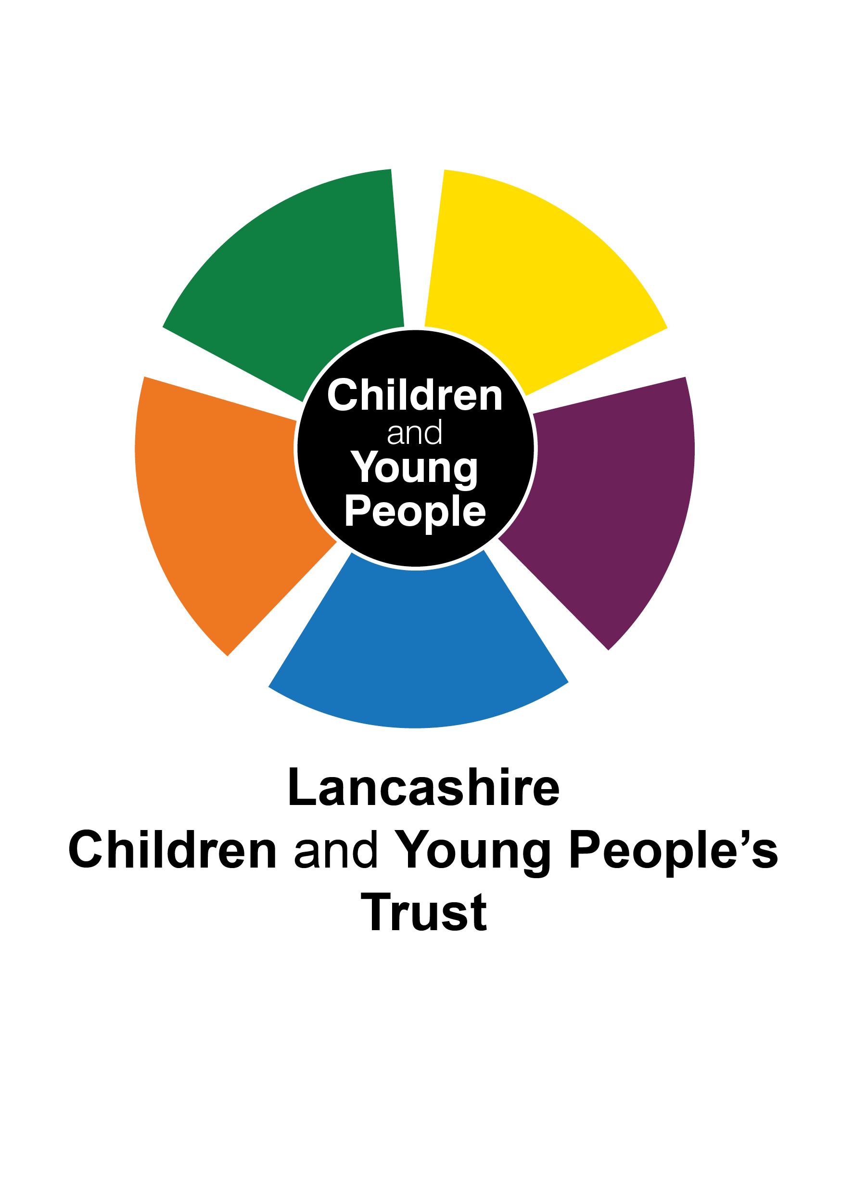
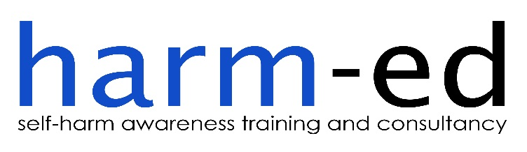

SELF-HARM TRAINING

COMMISSIONED BY LANCASHIRE COUNTY COUNCIL’S
CHILDREN AND YOUNG PEOPLE’S
INTEGRATED HEALTH TEAM

EVALUATION REPORT
2nd Commission: April 2015

CONTENTS
Page

Section 1 - Project Summary 1
Background
Research showing links between self-harm and suicide in children and
young people 1
National strategy: `Preventing Suicide in England’ 1
Self-harm in children and young people in Lancashire 2

Development of Self-Harm Training Programme
Lancashire County Council’s strategy for tackling self-harm in CYP 2

Section 2 - Service Description 3

Section 3 - Service Delivery 4
Suitability of harm-ed as a training provider 4
Service design and allocation of training places 4
Treating service-users as partners 9

Section 4 - Quality and Outcomes Performance Standard 13
Harm-ed’s performance against activity/process performance indicators
Production of training delivery plan 13
Provision of progress reports 13
Monitoring meetings attended 14
Number of training courses delivered 14
Total number of course participants 14
Number of members of the CYPTW attending by sector/district 14
Evaluation of the impact that the training has had within schools and with CYP 16
Harm-ed’s performance against quality/outcomes performance indicators
Comparing actual outcomes against target outcomes 17
Impact of training on CYPTW members 19
Value for money 20
1.0 PROJECT SUMMARY
Background

Research showing links between self-harm and suicide in children and young people
1.1 Research studies have shown that, by age 15-16, 7-14% of adolescents will have self-harmed once in their lifetime (Hawton K, Rodham K, Evans E and Weatherall R (2002) Deliberate self-harm in adolescents: self report survey in schools in England). Evidence shows that people who self-harm are at increased risk of suicide, although many people do not intend to take their own life when they self-harm (Cooper J, Kapur N, Webb R et al (2005) Suicide after deliberate self-harm: a 4-year cohort study). At least half of those who take their own life have a history of self-harm, and one in four have been treated in hospital for self-harm in the preceding year. Around one in 100 people who self-harm take their own life within the following year. There is increased risk of suicide in those who repeatedly self-harm and in those who have used violent/dangerous methods of self-harm (Runeson B, Tidemalm D, Ddahlin M et al (2010) Method of attempted suicide as predictor of subsequent successful suicide: national long term cohort study).

National strategy: `Preventing Suicide in England’

1.2 The `Preventing Suicide in England’ cross-government outcomes strategy (HMG/DH, 2012) supports the delivery of training on suicide and self-harm for staff working in schools and colleges as an effective local intervention in reducing the risk of suicide in children and young people (CYP):
'The non-statutory programmes of study for Personal, Social, Health and Economic (PSHE) education provide a framework for schools to provide age–appropriate teaching on issues including sex and relationships, substance misuse and emotional and mental health. This and other school-based approaches may help all children to recognise, understand, discuss and seek help earlier for any emerging emotional and other problems.

The consensus from research is that an effective school-based suicide prevention strategy would include:
- a co-ordinated school response to people at risk and staff training;
- awareness among staff to help identify high risk signs or behaviours (depression, drugs, self-harm) and protocols on how to respond;
- signposting parents to sources of information on signs of emotional problems and risk;
- clear referral routes to specialist mental health services'.

The `Preventing Suicide in England’ strategy supports the delivery of appropriate training on suicide and self-harm for staff working in schools and colleges as an effective local intervention in reducing the risk of suicide in this high risk group.

Self-harm in children and young people in Lancashire

1.3 In September 2013, a Joint Strategic Needs Assessment found that in 2011/2012 Lancashire ranked as one of the top 20% authorities in terms of high numbers of hospital admissions resulting from self-harm (391 emergency hospital admissions each year due to self-harm amongst CYP aged 0-17 in Lancashire-12). The rate of 160.5 admissions per 100,000 population was significantly worse than the rate across England (28% higher), and higher than the regional rate.

1.4 As part of Lancashire’s Emotional Health and Wellbeing Commissioning Strategy, a series of stakeholder events were held during 2013. A consistent and recurring theme arising was the concern from professionals working with CYP who feared they may be missing cues in respect of self-harm and who did not feel confident in addressing self-harm issues with children, young people and their families. In addition, CYP strongly support training for staff which help them recognise signs and symptoms, promote coping strategies and identify services that can offer additional support.

1.5 Child and Adolescent Mental Health Services (CAMHS) in Lancashire have reported an increase in demand for their services, including an increase in referrals in respect of self harm.

1.6 An in-depth review on suicide and self-harm in Lancashire, undertaken in 2012 by the Child Death Overview Panel, highlighted the importance of professionals to have the appropriate skills to enable them to engage with CYP effectively; research shows that such a skill set is all the more important when seeking to engage with those young people who do not necessarily want to engage (Devaney, J, Bunting, L, Davidson G, Hayes, D, Lazenbatt, A, and Spratt, T (2012), Still Vulnerable, The Impact of Early Childhood Experiences on Adolescent Suicide and Accidental Death; Northern Ireland Commissioner for Children and Young People).

1.7 Any training course would necessarily need to incorporate advice to staff in respect of self-harm contained in Lancashire Safeguarding Board procedures. Further post-course training could be provided by the emotional health and wellbeing suite of e-learning modules, including one on suicide and self-harm.
1.8 In March 2014, Lancashire County Council (LCC) commissioned harm-ed Limited (harm-ed) to deliver 10 training courses relating to CYP who self-harm to members of the CYPTW across Lancashire. Due to high levels of unmet demand for training places, harm-ed voluntarily ran 2 further training courses under this contract and LCC then commissioned harm-ed to deliver a further 3 training courses. In total, 265 participants attended these 15 courses (collectively referred to throughout this report as `the first commission’).

Development of Self-Harm Training Programme

Lancashire County Council’s strategy for tackling self-harm in CYP
1.9 In order to address the serious issues of self-harm in CYP (CYP) in Lancashire, and with the aim of reducing the incidence of suicide in this high risk group, LCC’s Children and Young People’s Integrated Health Team put out to tender its second comprehensive self-harm training programme across the whole of Lancashire in June 2014 (the `second commission’). Following its successful tender, harm-ed was commissioned to undertake this work in line with the terms stated in LCC’s Service Specification.
1.10 The Children and Young People's Integrated Health Team (since renamed Prevention and Early Help Service) was responsible for overseeing this service and for providing strategic direction, support and challenge to this commissioning arrangement. The commission provided for fortnightly progress updates to be provided by harm-ed; monthly monitoring returns and attendance at monthly monitoring meetings.
2.0 SERVICE DESCRIPTION

2.1 The overall aim of this service was to design, deliver and evaluate 10 full-day training courses between September 2014 and March 2015 on the subject of CYP who self-harm to members of the Children, Young People’s Trust Workforce (CYPTW) across Lancashire. Members of the CYPTW include the voluntary sector and cover eight different sectors, namely early years; education; health; social, family and community support; sports and culture; youth; justice and crime prevention and the managers and leaders of children's and wider public services.
2.2 One of the core objectives of the service was to deliver the training “across Lancashire ensuring equity of access and an even representation of the workforce” and one of the key outcomes was to ensure that participants were made aware of services which could be accessed locally throughout Lancashire in order to provide effective support to CYP who self-harm. This therefore required a county-wide approach to the delivery of self-harm training.
2.3 The service was designed so as to contribute to the priorities identified in Lancashire's Children & Young People Plan and the emerging priorities of the Lancashire Emotional Health and Wellbeing Commissioning strategy. A comprehensive list of expected outcomes was stated in the Service Specification, with the overall outcome expected of the service stated as:
“members of the children, young people and families workforce are equipped with the knowledge, skills and confidence they need to support young people who self harm through the delivery of face to
2.4 Harm-ed was tasked with, inter alia, delivering on the following expected outcomes:
- liaising with the Social Care Development Officer to identify training dates for staff from residential children’s homes. It should be noted that a number of residential children’s homes throughout Lancashire attended the training; these were grouped into the social, family and community support sector;
- managing recruitment of participants including provision of suitable venues;
- delivering training to a minimum of 150 people (maximum of 15 participants per course). Training was to be delivered within a locality footprint whilst ensuring equitable access across Lancashire, and should be at least one day’s duration; and
- evaluating the impact of the programme against the expected outcomes.
2.5 There was a further requirement for whole system relationships to be promoted across the different sectors of the CYPTW, and this resulted in harm-ed producing an effective allocations system to ensure that there was diverse representation on each of the training days. Harm-ed produced for LCC’s Commissioner Lead (referred to hereafter as `LCC’) a breakdown of partners attending each course per sector and per borough in order to demonstrate the spread of organisations receiving self-harm training (see example at 3.28 below).
3.0 SERVICE DELIVERY

Suitability of harm-ed as a training provider
3.1 Harm-ed Limited is a specialist, user-led, self-harm training and consultancy organisation established in 2007. It is a Lancashire based not-for-profit organisation which delivers training on both a local and a national level for partners including social services, schools, colleges, mental health services, young people’s centres, residential children’s homes, homeless organisations for young people and young people’s addiction services.
3.2 Harm-ed has an established team of well-respected trainers who have direct personal experience of self-harm within the care system, within the South Asian community, and arising from personal and professional experience of supporting people who self-harm.
3.3 Much of harm-ed’s work has been with young people’s services and has included delivering training to staff working directly with young people within educational services; ‘care’ settings; health and social care services; the Criminal Justice System; substance misuse services; young people’s homeless services; children’s resource centres and young people’s centres; and South Asian community family support services.
3.4 Harm-ed is regarded as an authority on self-harm and is regularly commissioned to draft public service policy documents relating to self-harm, and has published a number of articles in mental health journals, as well as co-writing books on self-harm.
Service design and allocation of training places
3.5 Harm-ed worked collaboratively with LCC to ensure that coverage of the training courses was as widespread as possible. A `map’ was created of the relevant CYP services within the eight sectors identified, and harm-ed was greatly assisted by LCC in identifying and targeting potential participants. A flyer was designed by harm-ed to promote the training courses; this was distributed by both harm-ed and LCC on harm-ed’s behalf. Training courses were also advertised in the CYP Trust e-bulletin and on the Lancashire schools portal.
3.6 In relation to the reserve list of 66 participant names that had been generated during LCC’s first commission for self-harm training, harm-ed contacted everyone on this list to offer them a place on one of the newly-scheduled courses. Surprisingly, given the extremely high demand for training places arising from the first commission of training courses, the take-up of places by those on the reserve list was relatively low, at only 35%. Reasons for this low take-up of training places include applicants being no longer in post or on long-term absence from office resulting in non-delivery of emails; participants no longer requiring a place following the cascading of information by previous training partners within the organisation or a subsequent request by the organisation for their own in-house self-harm training; and participants being unable to attend themselves but putting forward a colleague’s name by way of substitution. In the latter case, the substitute was only offered a place if it was found that the organisation had not previously accessed a place on one of the earlier courses. Where the organisation had previously accessed 1 or 2 places on a previous course, then the substitute’s name was not viewed as a `priority reserve’ and was instead placed on the normal list of applicants and the usual allocation procedure was applied.
3.7 Of the 66 names on the reserve list from the first commission, harm-ed and LCC allocated 23 training places. Figure 1 shows a breakdown per sector of the reserve list training partners attending one of the 10 second commission training courses.
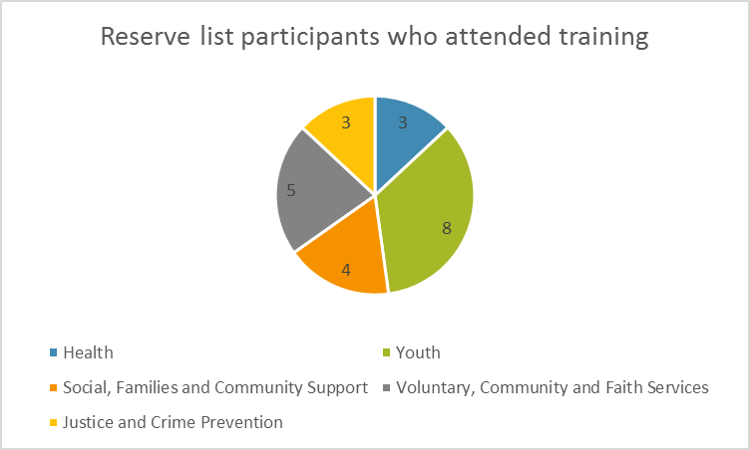
Figure 1: Breakdown of participants per sector who attended training from reserve list
3.8 Care was taken at all times to ensure that each training course represented the diversity of the services supporting CYP and care was also taken to provide a mix of boroughs to facilitate the sharing of good practice/networking. This was achieved for all courses.
3.9 Figure 2 shows the total number of training places requested per sector, broken down into the number of places allocated per sector and number of participants per sector who have been placed on the latest reserve list. This shows that a total of 324 new training places were applied for (despite harm-ed having received 412 requests for booking forms), and a total of 182 training places were offered, of which 172 training partners attended the training. This means that 142 potential participants have been added to the reserve list. These 142 names will be contacted as part of LCC’s third (March 2015) commission for training courses relating to CYP who self-harm.
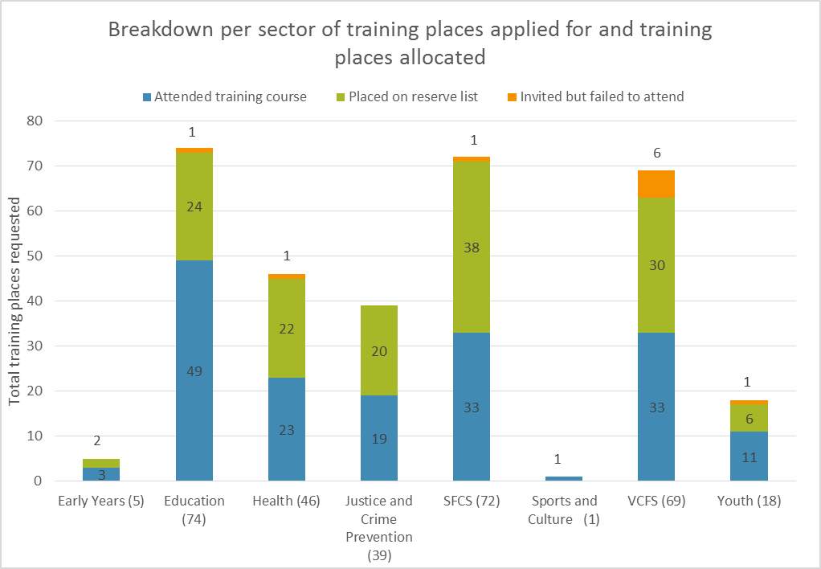
Figure 2: Total training places requested, broken down into places allocated and numbers of applicants on reserve list due to excess in demand for places.
3.10 Where organisations have several names listed on the reserve list, this reflects the fact that they are county-wide services and that participants represent different boroughs of Lancashire.
3.11 Figure 3 (overleaf) shows the breakdown of reserve places per borough.

Figure 3: Number of applicants on reserve list, per borough
3.12 Overall, there was a good spread of sectors on the reserve list for each borough, with the exception of Blackburn with Darwen where 8 of the 9 training partners on the reserve list were from the Health sector (East Lancashire Hospital – see 4.17 below); Flyde where 4 of the 5 training partners on the reserve list were from the SFCS sector; and Preston where 10 of the 21 training partners on the reserve list were from the VCFS sector.
3.13 Unlike the first commission for training courses, when harm-ed was met with an overwhelming deluge of applications for training, including multiple applications per service/organisation, the marketing in respect of the second commission has been met with consistently high but more manageable levels of demand. This is partly due to harm-ed’s greater understanding of the geographical boundaries of Lancashire and a greater awareness of applicants of the limitations placed on the allocation of training places. For example, this series has not attracted the same levels of demand for multiple places, nor such high levels of demand from organisations that do not provide services to or support for CYP. Only one request for multiple places was received – from North West Community Services Limited who requested 11 places. Due to this being a service which supports adults and without any acknowledgement of support being given to CYP, no training place could be offered.
3.14 At LCC’s request, harm-ed prioritised the marketing of the flyer through the school portal before sending it out through other channels, including the CYP e-bulletin and harm-ed’s own mailing lists. The main rationale behind this decision was due to the fact that the Education sector has the largest concentration of CYP and schools have previously been identified as struggling to cope with the issue of self-harm in CYP.
3.15 Once the allocation procedure was underway, harm-ed focussed on meeting demand from within the Education sector for the above reasons. However, where more than one applicant per school was made, then only one training place was offered and surplus names were entered onto the reserve list.
3.16 Overall, the same allocations criteria which had been agreed between LCC and harm-ed during the first commission were applied for this second commission. Therefore, as a general rule, only one place per course per service was allocated unless a late cancellation arose in which case the main aim was to fill all available places. Care was also taken to analyse the roles of the applicants where more than one application was received from the same organisation/service; if the roles were completely different, then discretion was applied so as to allocate the number of training places requested. As before, greater leniency was extended to services which were regarded as `county-wide’.
3.17 During the first commission, 8 organisations requested a total of 79 training places in total. Due to the strict allocations criteria which were applied, this demand could not be met and these organisations were encouraged instead to cascade information from those staff members who attended one of the first commission’s training courses, or to consider booking their own in-house training course. Four organisations who had accessed a place on the first series of courses then went on to request their own in-house training course. Only one application for multiple places was made during this second commission (see 3.13 above).
3.18 Booking forms were sent out to interested parties and, once returned and a place allocated, they were sent a Course Outline; the Learning Outcomes; a compulsory Pre-Course Evaluation Questionnaire; and venue directions. On the booking forms, participants were asked to state their first choice, second choice and third choice of training date/venue.
3.19 As a general rule, participants were ordered based on their first choice of training date/venue. Where this could not be met, due to over-subscription on certain dates, then participants’ second and then third choices were offered. Allocation of training places was also shaped by harm-ed’s `hand-picking’ of participants who would collectively form the most diversely represented groups in order to enhance their learning experience during training (for example, see 3.28). Where multiples from the same service attended on a given date, these were often selected due to the fact that they represented different boroughs.
3.20 Harm-ed became aware of some services, for example within the Education sector, who were facing urgent issues relating to CYP self-harm and were unsure of how to deal effectively with these issues. This information came to light on returned booking forms, or during initial telephone or email enquiries. The decision was taken with LCC that priority would be given to placing such participants on early training courses (as discussed at 3.14).
3.21 If participants were offered a place on a date they had not selected, harm-ed explained the difficulties that had been faced and apologised, inviting the participant to discuss any difficulties relating to CYP who self-harm with harm-ed.
3.22 Those participants who could not be offered a place were contacted and offered a place on the reserve list should a place become available (see 3.6 to 3.12 above).
3.23 One week before each training course, harm-ed contacted participants via email to confirm their attendance. Any participants who were offered a place but were unable to attend were then invited in the first instance to find another substitute participant from within their organisation/service; these were recorded on a ‘Participant Tracker Report’. When no substitute was put forward, a participant from the reserve list was invited to attend, based on their `best fit’ from a multi-agency perspective for the training day in question.
3.24 As mentioned at 3.18 above, participants were asked to return their Pre-Course Evaluation Questionnaires prior to attending their training. Summaries were produced of the responses to the two key questions asked in this questionnaire (see 3.29 below). These were evaluated and course content further adapted to meet participants’ specific learning needs/expectations. One recurring theme expressed by participants on these forms was an interest in learning more about available local services. At the end of the first commission, harm-ed produced and distributed to participants a directory of local services using information gained from the local and area offices of CAMHS and ELCAS and contributions from participants who had attended the training. With this second commission, harm-ed attached a copy of the services booklet to the final pre-course reminder email sent a week before their course to participants (at 3.23). Participants were asked to read through this booklet prior to the course date so that any omissions, additions or amendments could be discussed during the training.
3.25 Following each training course, participants were asked to complete an End-of-Course Evaluation Questionnaire. A summary of quantitative and qualitative data was collated on an Excel spreadsheet, and a breakdown of end-of-course evaluation data was collated for each of the 10 course dates.
3.26 Harm-ed updated LCC on how each course had evaluated within 24 hours of the course.
Treating service-users as partners
3.27 Harm-ed has respected LCC’s desire to treat all service-users as partners of the service and has at all times sought to fully engage partners and involve them in shaping course content in order that the training specifically meets their needs and expectations. As a result of participant feedback from the first commission of training courses, the course hours on the second commission have been extended from 9.30am to 4.00pm, to 9.30am to 4.30pm.
3.28 Great care was taken by LCC and harm-ed to ensure that a meaningful balance was achieved for each course such that there was both geographical representation and the promotion of whole system relationships across the different sectors of the CYPTW (discussed at 3.19 above). Figures 4 and 5 below are demonstrative of this.
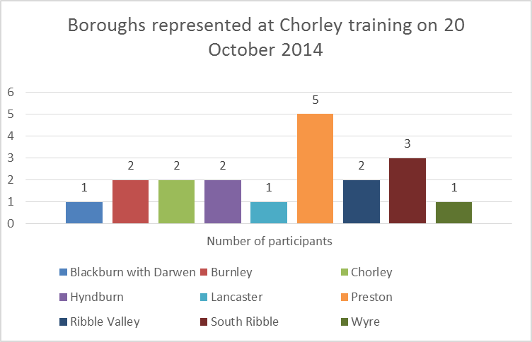
Figure 4: Chart showing range of boroughs represented at 20 October 2014 training course held at Chorley
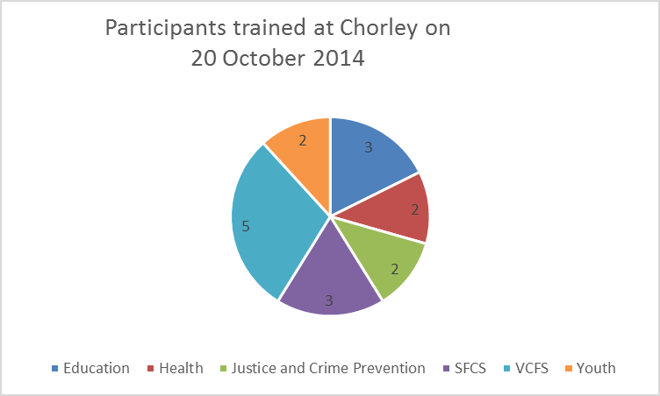
Figure 5: range of CYPTW members represented at 20 October 2014 training course held at Chorley
3.29 One of the ways in which harm-ed was able to involve partners in shaping course content was through their responses to the following two questions on the compulsory Pre-Course Evaluation Questionnaire:
- “Please describe any specific issues or areas of concern you have regarding self-harm that you would like to be addressed during the training”; and
- “Please state if there is anything else you hope to gain from this training course”.

3.30 The responses received were diverse in nature and demonstrated a keen desire amongst partners to improve both their own knowledge and understanding, and the quality and effectiveness of the support they could offer to CYP who self-harm. Furthermore, some responses highlighted the importance of effecting a culture change in the way in which partners perceive the reasons behind CYP self-harming. Below is a sample of responses selected from the Education sector in relation to Question 1.

- More in depth information on the signs that may indicate self-harm. As I work with primary age children I am aware that they are becoming a risk too, as it was always thought it was teenagers who self-harm
- I find myself with learners who have self-harmed in the past or are in a position where they are actively self-harming at the moment. And I would like to feel I am not making things worse for them and hopefully being of help.
- I would like to know more about how to support students who self harm and their families, also how to support their friends who are trying to cope with this too. I also have concerns about the incidents of self harm are on the increase and how other students seem to follow the actions of others
- How to approach the pupil so that they feel able to open up to you about their issues.
- What other help is out there for them.
- Are you allowed to approach parents without the child’s consent?
- How to work with and support school staff in their understanding and management of self-harm, tips of what to say and how to react when children show them their self-harm (helpful and unhelpful).
- I am interested in learning about any signs / indicators that a person may be self-harming, also in learning about how it is best to broach this subject with both children and parents and also how you should react / act in a professional role as a pastoral year head and also as a resident House tutor within an all-male boarding house.
- As a school we are concerned with the rise in numbers of young people who self -harm. I am interested in trying to raise awareness for staff, parents and young people of all aspects of self-harm, particularly prevention through the raising of confidence, self-esteem and education
- Just a general awareness around the subject and, as a primary school teacher, the main signs which may be apparent in younger children and how to approach this.
- Over the last few years in school we have seen an increase in young females particularly experimenting with self-harm individually and as a group. This has involved talking about it openly on social media and this has often impacted on their education and school life. I would like the training to help me recognise the danger signs and give some insight into how to help dealing with these situations and making sure we are helping the young people involved rather than making things worse.
- I am staggered at the number of pupils in my school that have or are self-harming in some way or another. I suppose I’m looking for ways we can avoid it happening as well of dealing with it when it is already happening.

3.31 Some cross-sector responses given to Question 2 included:

- I am relatively new to the Public Protection arena and Child Protection. I am keen to learn as much as possible around self-harm of children, particularly in the area of groups you would expect it to be more prevalent and how best to deal with self-harmers.
- To date, as a Newly Qualified Social Worker, I have no experience of working directly with children who have or are currently self-harming. However one of the children I am now allocated to regularly makes threats in school and I have recently referred him for emotional support to help him understand his responses to daily experiences and prevent this from escalating to 'physical self-harm'.
- I mainly work with children in residential care home settings where there is often superficial self-harm, however it is persistent. I would be interested in how to manage trends (mostly on the girls units) discouraging the imitating behaviour that often occurs in ‘in-patient’ facilities.
- What services are offered to young people who self harm in prison custody, once they are released? Also, could any links be made between prison and community staff to aid the young person once released from custody?
- Although Inspire is an adult service, we do now consider the whole family in our work with service users. As safeguarding lead for the East Lancashire substance misuse service, I am hoping that learning from this course will enable me to support practitioners in considering & recognising self-harm & associated risks, signs etc. in children & young people within their practice.
- How to recognise the signs for Self Harm and Sign Post to the correct organisation. We get a lot of young girls in our clinic and I feel we are missing opportunities to help them

3.32 One of the questions on the End-of-Course Evaluation Questionnaire, which participants were asked to complete before leaving, asked: In your opinion, do you feel the training met your needs/personal learning objectives? An analysis of the total responses to this question revealed that all 172 participants (100%) reported that the training had met the needs and personal learning objectives that they had expressed in their Pre-Course Evaluation Questionnaire.
3.33 As will be seen in section 4 of this report, consistently high levels of participant satisfaction with the training have been recorded.

4.0 QUALITY AND OUTCOMES PERFORMANCE STANDARDS

Harm-ed’s performance against activity/process performance indicators

Production of training delivery plan

4.1 The proposed training delivery plan provided in the initial tender for the first commission formed the basis of a discussion between LCC and harm-ed on 6 May 2014, when the following deadlines were agreed:
• Venues to be booked by 13 June
• Marketing flyer to be produced by 20 June
• Flyer to be distributed by 27 June
• A schedule of performance monitoring meetings was agreed
4.2 Harm-ed successfully met all agreed deadlines and attended all scheduled performance monitoring meetings.
Provision of progress reports
4.3 Prior to each and every course date, harm-ed submitted a list of participants to LCC detailing their role, organisation and location.
4.4 Regular contact was maintained with LCC re numbers of participants booking places on courses and numbers allocated to the reserve list.
4.5 Pre-course evaluation form feedback was collated and submitted in order that LCC could gauge participant expectations from the training. Any specific or unusual issues were drawn to LCC’s attention.
4.6 LCC was provided with a summary of each course’s end-of-course evaluation feedback, plus details of any non-attendees or extra participants attending.
4.7 Any specific issues arising from each training session were raised with LCC and dealt with promptly.
4.8 Copies of feedback received by email were promptly sent to LCC (for examples, see 4.23 and 4.28 below).
4.9 Regular telephone `meetings’ took place with LCC where emerging issues were discussed, eg, relating to eligibility, allocation, etc.
4.10 Ongoing email communication took place with LCC regarding any emerging issues that required clarification, eg, eligibility of enquiries; or number and nature of enquiries.
4.11 Interim statistical data was submitted to LCC at performance monitoring meetings. This data included numbers of overall requests for booking forms; number of booking forms received; number of overall participants who had attended training; and breakdown of sectors who had attended training courses.
Monitoring meetings attended
4.12 Monitoring meetings were attended at LCC premises from 10-12 on the following dates:
• 5 August 2014
• 24 September 2014
• 9 December 2014
• 24 March 2015

Number of training courses delivered
4.13 This second commission was for a total of 10 training courses, which were delivered in the following locations:
- Burnley – 2 training courses
- Chorley – 3 training courses
- Lancaster – 2 training courses
- Preston – 3 training courses

Total number of course participants
4.14 The second commission was to provide training for a minimum of 150 participants (see 2.4 above). However, harm-ed exceeded this target by 14.6%, training 172 participants in total. The breakdown of participants receiving self-harm training per training venue is as follows:
• Burnley – 34 course participants
• Chorley – 52 course participants
• Lancaster – 35 course participants
• Preston – 51 course participants

4.15 Due to the high levels of demand for this training, it was not possible to accommodate all requests for training. A reserve list was therefore created for those participants who registered an interest for training after all spaces had been allocated, or where it was necessary to place a limit on multiple requests from partner organisations for training. The reserve list currently stands at 142 unmet requests for training (see 3.9 above).
Number of members of the CYPTW attending by sector/district
4.16 A full breakdown of participants attending training courses, identifying both sector and district, was produced by harm-ed (see figures 6 and 7 below). This demonstrates the broad geographical spread per course together with consistent promotion of whole system relationships across the different sectors of the CYPTW (see 3.28 above).
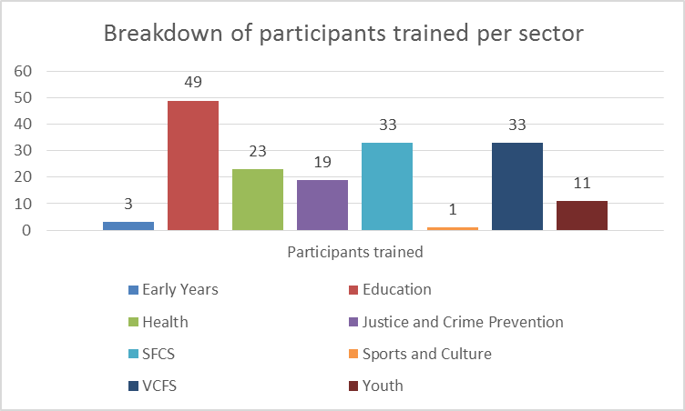
Figure 6 - breakdown of sectors receiving self-harm training.
Note a chart showing the total number of sectors attending training compared to total number of training places requested per sector is given at figure 2.
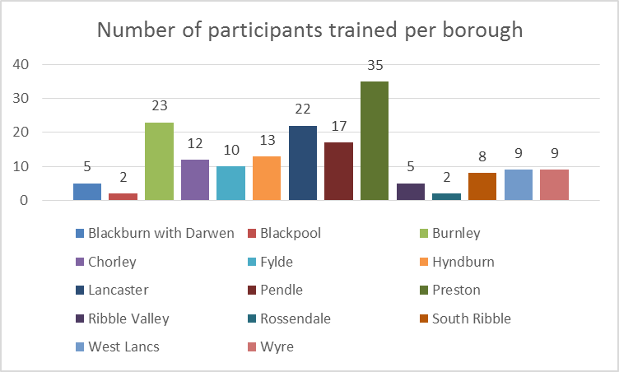
Figure 7 - breakdown of participants trained per borough
4.17 In figure 7, Blackburn with Darwen and Blackpool are both unitary authorities which do not fall within LCC’s geographical boundaries. However, participants from these authorities were permitted to attend the training where there was evidence that they supported CYP from within Lancashire County Council’s boundaries. For example, East Lancashire Hospital is based in Blackburn but admits and treats CYP from within East Lancashire which covers Burnley, Hyndburn and Pendle.

Evaluation of the impact that the training has had within schools and with CYP
4.18 The impact that this training will have on schools and on CYP throughout Lancashire is something that will be evidenced more fully over time, once training has been cascaded down through the various services.
4.19 A recent Impact Assessment Study conducted by harm-ed on behalf of LCC in March 2015 has demonstrated that training under the first commission has had a very positive impact in terms of helping participants to:
- understand the complex nature of self-harm in CYP;
- recognise at an earlier stage risk factors associated with self-harm and signs that a CYP may be self-harming;
- feel more confident in broaching the subject of self-harm with a CYP they suspect of self-harming;
- focus their support on addressing the cause of the self-harm rather than the action itself;
- make more timely and effective referrals; and
- reduce the incidence, frequency and severity of self-harm in CYP.
4.20 The same Study has shown that CYP have also felt the benefits of the support that is now being offered by those who have attended self-harm training; in particular, they have responded very positively to the open, empathic and non-judgmental approaches that are now being adopted by those who attended the training.
4.21 An analysis of the End-of-Course Evaluation Questionnaire illustrates that the training has had an extremely positive impact on those participants who represented schools throughout Lancashire. 100% of training participants from the Education sector reported that their needs and personal learning objectives had been fully met by the training, and that they now had an increased knowledge of self-harm; and an increased confidence in the subject area. All Education sector participants, except one, reported having an increased confidence in being able to support young people who self-harm. One participant responded “N/A” to this question, but explained that this was because she already felt very confident in her ability to support CYP who self-harm.
4.22 The qualitative data collated from the End-of-Course Evaluation Questionnaires demonstrates very high and consistent levels of satisfaction within schools and other participants representing the Education sector. It also demonstrates a clear determination by participants to apply their new knowledge in the workplace. For example, several participants listed these as the most useful aspects of the training:
- “It has been really useful to learn how to talk to someone about issues. Focussing on emotional problems! Not stopping self-harm.” Head of Year, High School
- “I have gained a further insight and understanding of self-harm and issues that contribute/impact on YP.” Pupil Attendance Team
- “I feel better knowing what to do when someone self-harms. Make sure I am doing the right thing.” Emotional First Aider, College
4.23 Further positive feedback was received post-course from schools via email. For example:

- “Thank you for such an enjoyable and emotive course, it was one of the best courses I've been on for a long time. It certainly filled me with the confidence I needed to be able to work with young people effectively” Pastoral Manager, High School
- “Thank you, I really enjoyed the course. In fact I have just this minute spoken to a parent about self-harm and found that I was far more confident in trying to help than before.” Learning Mentor, Secondary School
- “I found yesterday enlightening and extremely helpful.” Assistant Head Teacher, High School
- “I wanted to offer you a heartfelt thank you for the training. It was the most useful and practical training I have been on in a very long time and training I know I can put into practice if I needed to” SENCO, Primary School
- “Many thanks for the excellent training, it was informative and extremely helpful and gave me a real insight into the issue of self-harm, which is the one area of Child Protection I feel in my previous training has been least addressed” Assistant Head, Primary School

Harm-ed’s performance against quality/outcomes performance indicators
Comparing actual outcomes against target outcomes
4.24 LCC set a number of quality and outcomes performance indicators against which harm-ed collated quantitative and qualitative data from End-of-Course Evaluation Questionnaires. These quality and outcomes performance indicators were based on the number of End-of-Course Evaluation Questionnaires completed. It should be noted that all 172 participants completed their End-of-Course Evaluation Questionnaire.
4.25 Harm-ed produced a breakdown for LCC of all outcomes achieved against targets, together with qualitative data collated, for each course run.
4.26 Figures 8 and 9 (below) show that, against each and every performance indicator, harm-ed has exceeded targets set – in most cases achieving 100% against target outcomes.
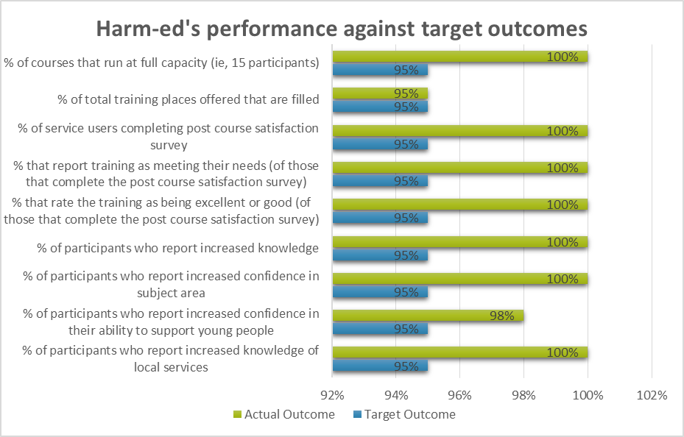
Figure 8 - Harm-ed's performance against target outcomes

Outcome | Target | Actual
% of courses that run at full capacity (i.e. 15 participants) | 95% | 100%
% of total training places offered that are filled | 95% | 95% *
% of service users completing post course satisfaction survey | 95% | 100%
% that report training as meeting their needs (of those that complete the post course satisfaction survey) | 95% | 100%
% that rate the training as being excellent or good (of those that complete the post course satisfaction survey) | 95% | 100%
% of participants who report increased knowledge | 95% | 100%
% of participants who report increased confidence in subject area | 95% | 100%
% of participants who report increased confidence in their ability to support young people | 95% | 98%**
% of participants who report increased knowledge of local services | 95% | 100%

Figure 9 - Harm-ed's performance against target outcomes

Notes:
* Each of the training courses was initially booked to maximum capacity. On the day of the courses, a total of 10 participants did not show up and therefore harm-ed were not given the opportunity to send replacement participants. Therefore, although harm-ed exceeded the minimum number of training places by 14.6%, with 172 people attending the courses, this was 5% less than the 182 expected to attend.
** Of the three participants who either indicated “No” or “N/A” against this question, two did so because they already felt very confident in their ability to support young people and the third had no direct contact with CYP so did not feel that the question applied to him.
4.27 Overall, 165 (96%) of participants described the training as “excellent”.
Impact of training on CYPTW members
4.28 The above performance data supports the fact that the self-harm training delivered by harm-ed Limited has had a significant and positive impact on all CYPTW members attending. Further evidence of this can be seen in a small selection of the many positive feedback comments that have been either left on completed End-of-Course Evaluation Questionnaires or sent post-course by email:
- “I really enjoyed the training. I found it extremely interesting and now feel much more confident in the work I do” Detective Constable
- “Thank you for today, it was one of the most inspirational training courses I have ever attended” Social Worker
- “Just want to say I found the training very informative and really interesting— Regan and your good self are a true inspiration keep up the good work” Family Support Worker, CSC
- “Thank you and what a brilliant day, I learnt so much. I understood a bit more of the ‘why’ which was what I wanted” Review Officer, Public Protection Unit
- “Interesting, valuable and inspiring. The experiential conversations and insights made it so personal” Paediatric Liaison Mental Health, ELCAS
- “It was all brilliant, best training I have ever been on” Family Employment Advisor, Via Partnership.
- “The most useful aspects were the personal experience and keeping it real - makes the subject and feelings seen from the perspective of those in distress and their carers very inspirational.” Paediatric Staff Nurse
- “I found the `What if' concept - powerful. Also what young people find helpful. The reassurance that our communication is helpful, and not necessary to refer on.” Sexual Health Nurse
- “It was great to pick up some strategies to use and what to say/not to say.” Young People’s Mentor

Value for money
4.29 Efforts were made throughout this contract to keep costs to a minimum. Although LCC venues were to be used for the training courses, those which did not charge were approached first. However, the multi-agency nature of the participants made this option non-viable.
4.30 The original contract price was £23,000 with a target of training a minimum of 150 participants on at least 10 different training days. Based on these targets, the cost per head would be as follows:
Cost of service | Total participants trained | Cost per head
£23,000 | 150 | £153.33

Figure 10 – cost of training per head under initial contract price

4.31 To take account of historic evidence of non-attendance (estimated at 20%), and to fully utilise each course to meet the high levels of demand, harm-ed operated an over-booking system. This resulted in all 10 courses being over-subscribed. All courses had between 16 and 19 participants and Harm-ed bore the additional subsistence costs involved.
4.32 As a total of 172 participants received training under the second commission, this meant that the cost per head was £133.72, representing a saving per head of £19.61. Had the cost per head in figure 10 been applied for all 172 participants trained, then this would have cost £26,372.76, representing 14.6% more than the total funding for this service. This therefore represents value for money in terms of public expenditure.
4.33 If, as is expected, the training received is now cascaded down through the different organisations attending, then the number of CYPTW members indirectly benefiting from the knowledge being shared and procedures being established as a result of the self-harm training will expand, making the ultimate cost per head minimal.

