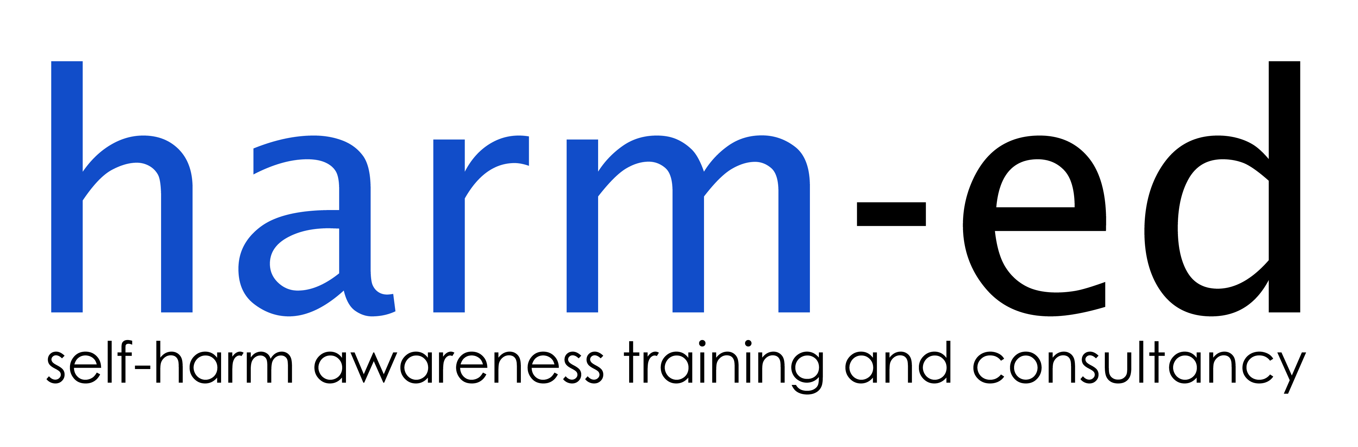
Lancashire Collaborative
Partnership of Clinical Commissioning Gro8ups

- Lancashire CAMHS Transformation Board has commissioned harm-ed to deliver a series of free full-day training courses on “Children and Young People who Self-Harm” throughout Lancashire.
- The `Preventing Suicide in England’ cross-government outcomes strategy (2012) supports the delivery of training on suicide and self-harm for staff working in health, social care and education as an effective local intervention in reducing the risk of suicide in children and young people.
- Children and young people are at high risk of self-harm. By age 15-16, 7-14% of adolescents will have self-harmed once in their life. People who self-harm are at increased risk of suicide.
- Allocation of places is limited to the children and young people’s workforce across Lancashire, with priority given to the health, social care and education sectors. Applications will also be accepted from wider children and young people’s services.
- Training will be `multi-agency’ and therefore the need to ensure equal access across different sectors/services may result in limits being placed on the number of places available per service per course.
- The course is suitable for staff/carers working at all levels across all relevant sectors. Below are examples of previous feedback for this training:
- “This was by far the best training I have ever attended” (Early Action Police Officer, 27 October 2016)
- “The training was absolutely FAB!! In fact probably the most interesting/useful and relevant training I have ever been on” (Senior CAMHS Practitioner, 24 October 2016)
- “The training was brilliant and from today my approach to young people who self-harm will change for the better” (Pastoral Manager, 7 February 2017)
Training Venue Training Dates
BURNLEY Turf Moor Football Stadium March 29
FYLDE AND WYRE NHS Fylde and Wyre CCG HQ, Wesham March 28
LANCASTER NHS North Lancs CCG HQ, Moor Lane Mills March 24, April 10
PRESTON Lancashire Conservation Studios March 30
SKELMERSDALE JMO Sports Park April 6

A booking form is available from camhs@harm-ed.co.uk

