Lancashire Collaborative
Partnership of Clinical Commissioning Groups

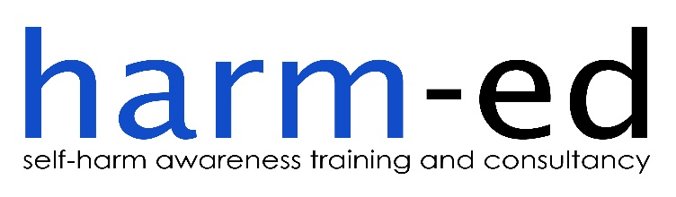

SELF-HARM TRAINING
February 2017 to May 2017

COMMISSIONED BY
CAMHS Transformation Board in Partnership with
NHS Lancashire Clinical Commissioning Groups

EVALUATION REPORT

CONTENTS
Page
Definitions and acronyms
Section 1 - Project Summary 1
Background
Research showing links between self-harm and suicide in children and
young people 1
National strategy: `Preventing Suicide in England’ 1
Self-harm in children and young people in Lancashire 2
Development of Self-Harm Training Programme
Lancashire CCGs’ strategy for tackling self-harm in CYP 2
Section 2 - Service Description 3
Outcomes 5
Outputs 5
Section 3 - Service Delivery 6
Suitability of harm-ed as a training provider 6
Service design and allocation of training places 6
Treating course participants as partners 15
Section 4 - Quality and Outcomes Performance Standard 19
Harm-ed’s performance against activity/process performance indicators
Production of training delivery plan 19
Provision of progress reports 19
Number of training courses delivered 20
Total number of course participants 21
Number of applicants receiving training per sector 21
Evaluation of the impact that the training has had within health, education
and social care sectors and with CYP 22

Harm-ed’s performance against quality/outcomes performance indicators
Comparing actual outcomes against target outcomes 27
Impact of training on staff working within CYP services 29
Value for money 30
Page
Section 5 – Recommendations 31
Appendices 33
Appendix 1 – Course dates and costings
Appendix 2 – Memorandum of Agreement
Appendix 3 – Harm-ed course learning outcomes
Appendix 4 – End-of-course evaluation questionnaire template
Appendix 5 – Harm-ed Limited’s Service Specification
Appendix 6 - Breakdown of partners attending each course
Appendix 7a - Marketing flyer – March to Easter courses
Appendix 7b - Marketing flyer – Easter to May courses
Appendix 8 - Harm-ed Limited’s Allocations Policy
Appendix 9a - Booking form – March to Easter courses
Appendix 9b - Booking form – Easter to May courses
Appendix 10 – Course outline
Appendix 11 – Pre-course evaluation questionnaire template
Appendix 12 – Participant tracker spreadsheet
Appendix 13 – End-of-course evaluation questionnaire spreadsheet per training course

List of Figures Page
Figure 1: Breakdown of the 50 participants on reserve list (per sector) at the end of East Lancashire CCG
and Blackburn with Darwen CCGs’ second training commission ending March 2017 7
Figure 2: Breakdown of applicants per sector who were ineligible to attend training 8
Figure 3: Breakdown of applications received for multiple places 9
Figure 4: Breakdown per sector of total applications received 10
Figure 5: Breakdown of applications received per CCG/area 10
Figure 6: Breakdown of training places allocated per CCG 11
Figure 7: Total applicants on final reserve list, represented by sector 14
Figure 8: Total under 16s’ service providers on final reserve list, represented by sector 14
Figure 9: Total applicants on final reserve list, represented by CCG area 15
Figure 10: Chart showing different CCG areas represented at Fylde and Wyre course on 28 March 2017 16
Figure 11: Sectors represented at Wesham, Fylde and Wyre on 28 March 2017 16
Figure 12: Number of training courses delivered per CCG/area 20
Figure 13: Breakdown of participant totals per training venue 21
Figure 14: Breakdown of total applicants per sector compared to total participants trained 22
Figure 15: Chart showing Harm-ed's performance against target outcomes 28
Figure 16: Table showing Harm-ed's performance against target outcomes 29
Figure 17: Cost savings per head resulting from actual participants’ trained exceeding target number 31

DEFINITIONS AND ACRONYMS

CAMHS Child and Adolescent Mental Health Services
CCGs NHS Clinical Commissioning Groups (CCGs) for Lancashire comprising Blackpool, Central Lancashire, Fylde and Wyre, North Lancashire, Pennine and West Lancashire
CL CCGs Commissioning Lead
CYP Children and young people
CYPFW Children, Young People and Families’ Workforce
CYPTW Children and Young People’s Trust Workforce
JCP Justice and Crime Prevention
LCC’s CYPIHT Lancashire County Council’s Children and Young People’s Integrated Health Team
MoA Memorandum of Agreement
SFCS Social, Family and Community Support
VCFS Voluntary, Community and Faith Sector

1.0 PROJECT SUMMARY
Background
Research showing links between self-harm and suicide in children and young people
1.1 Research studies have shown that, by age 15-16, 7-14% of adolescents will have self-harmed once in their lifetime. Evidence shows that people who self-harm are at increased risk of suicide, although many people do not intend to take their own life when they self-harm. At least half of those who take their own life have a history of self-harm, and one in four will have been treated in hospital for self-harm in the preceding year. Around one in 100 people who self-harm take their own life within the following year. There is increased risk of suicide in those who repeatedly self-harm and in those who have used violent/dangerous methods of self-harm.
National strategy: `Preventing Suicide in England’
1.2 The `Preventing Suicide in England’ cross-government outcomes strategy supports the delivery of training on suicide and self-harm for staff working in schools and colleges as an effective local intervention in reducing the risk of suicide in children and young people (CYP):
'The non-statutory programmes of study for Personal, Social, Health and Economic (PSHE) education provide a framework for schools to provide age–appropriate teaching on issues including sex and relationships, substance misuse and emotional and mental health. This and other school-based approaches may help all children to recognise, understand, discuss and seek help earlier for any emerging emotional and other problems.
The consensus from research is that an effective school-based suicide prevention strategy would include:
- a co-ordinated school response to people at risk and staff training;
- awareness among staff to help identify high risk signs or behaviours (depression, drugs, self-harm) and protocols on how to respond;
- signposting parents to sources of information on signs of emotional problems and risk;
- clear referral routes to specialist mental health services'.

The `Preventing Suicide in England’ strategy supports the delivery of appropriate training on suicide and self-harm for staff working in schools and colleges as an effective local intervention in reducing the risk of suicide in this high risk group.
Self-harm in children and young people in Lancashire
1.3 In August 2014, a Joint Strategic Needs Assessment found that, in 2012/13, the rate of emergency hospital admissions due to self-harm among 10-24 year olds in the North-West was 25% higher than the rate across England. In Lancashire-12, there were around 1,073 such cases, equating to a rate of 476.3 admissions (per 100,000 population) which is 37.5% higher than the rate across England and over 10% higher than the rate across the North-West region. The corresponding figures for Blackburn with Darwen were 526 emergency hospital admissions per 100,000 of the population due to self-harm among 10-24 year olds, which is 51.9% higher than the national rate and 21.5% higher than the regional rate. Blackpool had the highest rate in the country in 2012/13, with 1,152.4 emergency hospital admissions (per 100,000 population) due to self-harm among 10-24 year olds. This is more than three times and 232.8% higher than the national average in England and more than double or 166% higher than the average for the whole of the North-West region.
1.4 As part of Lancashire’s Emotional Health and Wellbeing Commissioning Strategy, a series of stakeholder events were held during 2013. A consistent and recurring theme arising was the concern from professionals working with CYP who feared they may be missing cues in respect of self-harm and who did not feel confident in addressing self-harm issues with children, young people and their families. In addition, CYP themselves strongly support training for staff which can help them recognise signs and symptoms, promote coping strategies and identify services that can offer additional support.
1.5 Child and Adolescent Mental Health Services (CAMHS) in Lancashire have reported an increase in demand for their services, including an increase in referrals in respect of self-harm.
1.6 An in-depth review on suicide and self-harm in Lancashire, undertaken in 2012 by the Child Death Overview Panel, highlighted the importance for professionals to have the appropriate skills to enable them to engage with CYP effectively; research shows that such a skill set is all the more important when seeking to engage with those young people who do not necessarily want to engage.
1.7 Any training course would necessarily need to incorporate advice to staff in respect of self-harm contained in Lancashire Safeguarding Board procedures.
Development of Self-Harm Training Programme
Lancashire CCGs’ strategy for tackling self-harm in CYP
1.8 One of Lancashire CCGs’ (the CCGs’) strategies for tackling the serious issues of self-harm in CYP within Lancashire is to ensure that its CYPF workforce, including those working in health, education and social care, early action policing, family and community support groups, and leaders and carers within children’s services, are offered training on the subject of `children and young people who self-harm’. The underlying purpose of the training and the CCGs’ aims and objectives are stated at 2.4 and 2.5 below.
1.9 In January 2017, the CCGs invited harm-ed Limited to provide costings for the design, delivery and evaluation of 18 full-day training courses spanning February to May 2017; Appendix 1 contains harm-ed’s costings and proposed training dates. Harm-ed had already successfully delivered a series of similar contracts on behalf of the CYPTW, commissioned by Lancashire County Council’s Children and Young People’s Integrated Health Team (LCC’s CYPIHT), and on behalf of East Lancashire and Blackburn with Darwen CCGs. A Memorandum of Agreement (Appendix 2) set out the contractual terms of the CCGs’ commission.
1.10 As a joint commission, all CCGs within Lancashire were responsible for overseeing this service and for providing strategic direction, support and challenge to these commissioning arrangements. The commission provided for regular progress updates to be provided by harm-ed to each of the CCGs alongside monthly monitoring returns. East Lancashire CCG acted as the commissioning lead for this project (CL).
2.0 SERVICE DESCRIPTION

2.1 The overall aim of the service was to design, deliver and evaluate a series of 18 full-day training courses across the whole of Lancashire between February and May 2017. The subject of the training courses was ‘children and young people who self-harm’ and participants were invited from the Children, Young People and Families’ Workforce (CYPFW} throughout Lancashire. The CYPFW included members of staff from numerous organisations and different sectors, namely early years; education; health; social, family and community support (SFCS); sports and culture; youth; justice and crime prevention, and the managers and leaders of children's and wider public services. The voluntary sector is included across all eight sectors of the CYPFW.
2.2 One of the core objectives of the service was to deliver the training across Lancashire ensuring equity of access and an even representation across the workforce whilst prioritising applications and attendance from those applicants working within the health, education and social care sectors. Since CAMHS’ services are restricted to those children and young people aged 16 or under, services which solely supported young people aged 16 and over were ineligible to attend the training courses.
2.3 The service was designed so as to contribute to the priorities identified by the CCGs, CAMHS, Lancashire's Children & Young People Plan, and the Lancashire Emotional Health and Wellbeing Commissioning strategy.
2.4 The CCGs’ intention expressed in the MoA was that the training would be instrumental in reducing the incidence of suicide in this high risk group; addressing the high rate of emergency hospital admissions due to self-harm in CYP; minimising the risk of escalation to crisis point and the need for more intensive support such as that offered by CAMHS; and improving levels of understanding and effective signposting so as to more effectively support CYP who self-harm.
2.5 The CCGs’ core aims and objectives set the theme for harm-ed’s course learning outcomes (Appendix 3). The aims and objectives state that, at the end of each training course, participants would feel more able to:
- Recognise self-harm as a coping strategy for children/young people facing difficult feelings and situations
- Place self-harm on a continuum of other self-damaging behaviours, including suicide
- Demonstrate increased confidence in broaching the issue/managing disclosure with a child or young person who self-harms
- Identify the social, environmental and psychological factors which influence the prevalence of self-harm amongst children and young people
- Demonstrate an understanding of the functions that self-harm might be serving for the children/young people they are supporting
- Identify the signs that may indicate that a child or young person is self-harming
- Identify the barriers which might prevent a child or young person from disclosing or accessing support for their self-harm, and as a consequence, identify strategies that may help break down these barriers
- Demonstrate understanding in terms of reducing risk and in promoting a therapeutic relationship
- Demonstrate increased confidence in ability to offer a helpful response to a child/ young person who self-harms
- State the more common models of response to self-harm, including ‘alternatives to self-harm’
- Describe how the emotional impact of self-harm on staff/carers can affect the quality of support offered to children/young people as well as impacting on the staff/carer’s own mental well-being

Harm-ed’s end-of-course evaluation questionnaire (Appendix 4) was designed to elicit evidence from participants that these learning outcomes had been achieved.

2.6 A comprehensive list of expected outcomes was stated in the Memorandum of Agreement and in harm-ed Limited’s Service Specification (Appendix 5) as:
Outcomes
Participants, through their end-of-course evaluation questionnaires, can demonstrate:
- High levels of satisfaction with the training
- The training met the needs they expressed in their pre-course questionnaire
- Improved knowledge of self-harm in children and young people
- Improved confidence in the subject of children and young people who self-harm
- Improved confidence in ability to support children and young people who self-harm
- Improved knowledge of local services and support available

2.7 The following outputs were agreed between harm-ed and the CCGs:
Outputs
- Courses to be filled to capacity, i.e., minimum of 16 participants per day
- Delivering full-day (9.30am-4.30pm) training to at least 288 participants between February and May 2017

It was agreed between harm-ed and the CL that the target performance measure in respect of the above outcomes and outputs would be 95%.
2.8 Harm-ed was tasked, inter alia, with:
- liaising with the CL in relation to training dates, locations and participant allocation policies;
- managing recruitment of participants including provision of suitable venues;
- delivering training within a locality footprint whilst ensuring equitable access throughout the entire CYPFW within Lancashire;
- ensuring participant satisfaction is monitored; and
- evaluating the performance of the service against expected outcomes.

2.9 There was a further requirement for whole system relationships to be promoted across the different sectors of the CYPFW throughout Lancashire, and this resulted in harm-ed producing an effective allocations system to ensure that there was diverse representation on each of the training days. The CCGs wished for priority to be given to health, education and social care services, and for places to be restricted to those which provided services for those aged 16 and under. The breakdown of partners attending each course is given at Appendix 6.

3.0 SERVICE DELIVERY

Suitability of harm-ed Limited as a training provider
3.1 Harm-ed Limited is a specialist, user-led, self-harm training and consultancy organisation established in 2007. It is a Lancashire-based not-for-profit organisation which delivers training on both a local and a national level for partners including social services, schools, colleges, mental health services, young people’s centres, residential children’s homes, homeless organisations for young people and young people’s addiction services.
3.2 Harm-ed has an established team of well-respected trainers who have direct personal experience of self-harm within the care system, within the South Asian community, and arising from personal and professional experience of supporting people who self-harm.
3.3 Much of harm-ed’s work has been with young people’s services and has included delivering training to staff working directly with young people within educational services; ‘care’ settings; health and social care services; the Criminal Justice System; substance misuse services; young people’s homeless services; children’s resource centres and young people’s centres; and South Asian community family support services.
3.4 Harm-ed is regarded as an authority on self-harm and is regularly commissioned to draft public service policy documents relating to self-harm, and has published a number of articles in mental health journals, as well as co-writing chapters in books on self-harm.
Service design and allocation of training places
3.5 Harm-ed worked collaboratively with the CCGs to ensure that coverage of the training courses was as widespread as possible. A `map’ was created of the relevant CYP services within the different sectors identified, and harm-ed was greatly assisted by the CCGs in identifying and targeting potential participants. Two flyers were designed by harm-ed to promote training courses. Because of the speed with which harm-ed was required to commence delivery of the training courses, the first flyer (Appendix 7a) publicised available dates between March and the Easter period in April to ensure as much early take-up of courses as possible. The second flyer (Appendix 7b) publicised dates post-Easter and May 2017. The flyers were distributed by both harm-ed and the CCGs on harm-ed’s behalf.

3.6 Following the delivery of two self-harm training commissions from East Lancashire CCG and Blackburn with Darwen CCG spanning December 2015 to May 2016 and October 2016 to March 2017, there were 50 participant names still on harm-ed’s reserve list due to high levels of demand for training places. Figure 1 shows the breakdown per sector of participants on the reserve list. Where these participants were found to deliver services to children and young people aged 15 or under, and were from within Lancashire, they were the first to be sent a flyer and the first to be invited to apply for a place on the first raft of pre-Easter courses. The first flyer was then widely distributed by both harm-ed and the individual CCGs and, when the first six course dates were almost full, the second flyer was distributed.
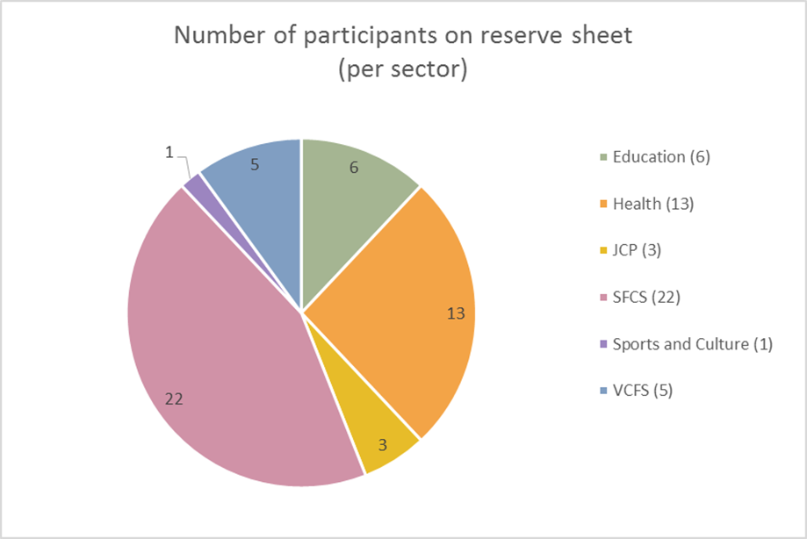
Figure 1: Breakdown of the 50 participants on reserve list (per sector) at the end of East Lancashire CCG and Blackburn with Darwen CCGs’ second training commission ending March 2017
3.7 Clarity was sought as to the allocations policy for applicants from Blackpool owing to the fact that a separate commission for training within that unitary authority was running simultaneously with a different provider. It was agreed with the CL and with Blackpool CCG that harm-ed would bear in mind the fact that Blackpool CCG had contributed to the funding for this current commission when allocating places to applicants from Blackpool.
3.8 The response to marketing was immediate and substantial, with high numbers of telephone enquiries and emails requesting booking forms. The levels of demand for this training were at their highest level since harm-ed’s first Lancashire County Council commission for 10 training courses in 2014. It is believed that this could be due to the wider geographical spread of this commission, being Lancashire-wide, although it should be noted that previous harm-ed commissions have not placed the restriction that service providers should support children and young people aged 15 or under. In total, 582 requests for training places were made, 53 of which were identified as ineligible – mainly by reason of location, or being service providers to adults or over-15s (see figure 2). Only those applicants whose roles entailed providing services or support to CYP aged 15 or under within Lancashire were eligible to attend the training courses.
3.9 As can be seen from figure 2, the main reason for 53 applicants being advised that they were ineligible to attend the training was due to them providing services for young people aged over 15. The majority of these applicants came from the Health and VCFS sectors. Three applications were made from organisations outside the area, but where these could satisfactorily demonstrate that their services reached relevant CCG areas (for example, the North-West Ambulance Service), these were allocated a training place or placed on the reserve list where no place was available.
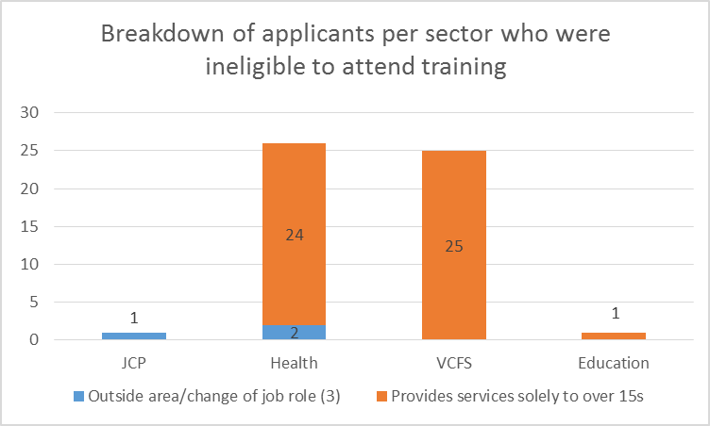
Figure 2: Breakdown of applicants per sector who were ineligible to attend training
3.10 Many organisations made multiple requests for training places which, due to levels of demand and the need for diversity of representation, could not be met. The number of places allocated to each provider was generally limited to two or three, although much depended on the total workforce/catchment area of the organisation, and the number of children and young people under 16 for whom there was relevant funding. In such cases, harm-ed contacted the organisation and explained the situation, asking them to nominate the participant(s) they would like to attend the training. By allocating limited spaces only per organisation/borough, the expectation was that key information/ knowledge gained during the training would be cascaded down within each organisation. Where a sufficient number of places was requested by the same organisation, harm-ed invited them to consider commissioning their own in-house self-harm training course. Figure 3 shows the breakdown of multiple applications received against the number of allocated places.

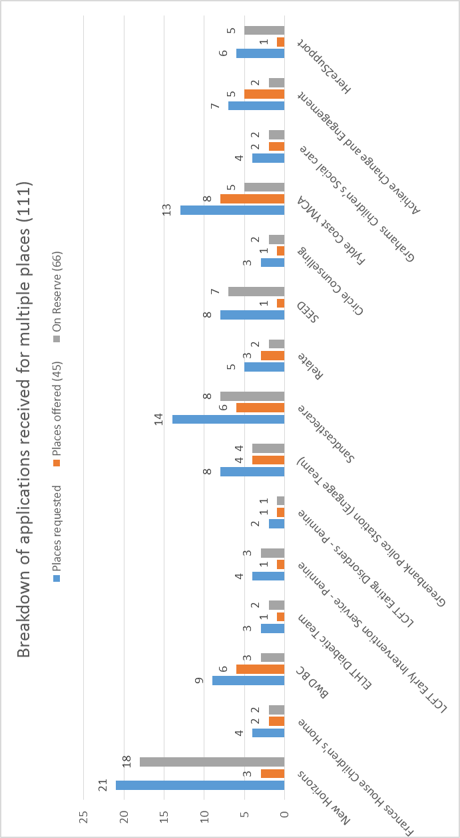
Figure 3: Breakdown of applications received for multiple places

3.11 Figures 4 and 5 provide a breakdown of the 582 applications received – by sector and by CCG/area.
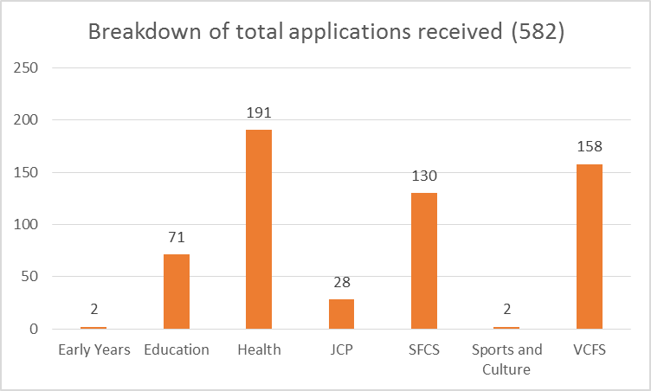
Figure 4: Breakdown per sector of total applications received
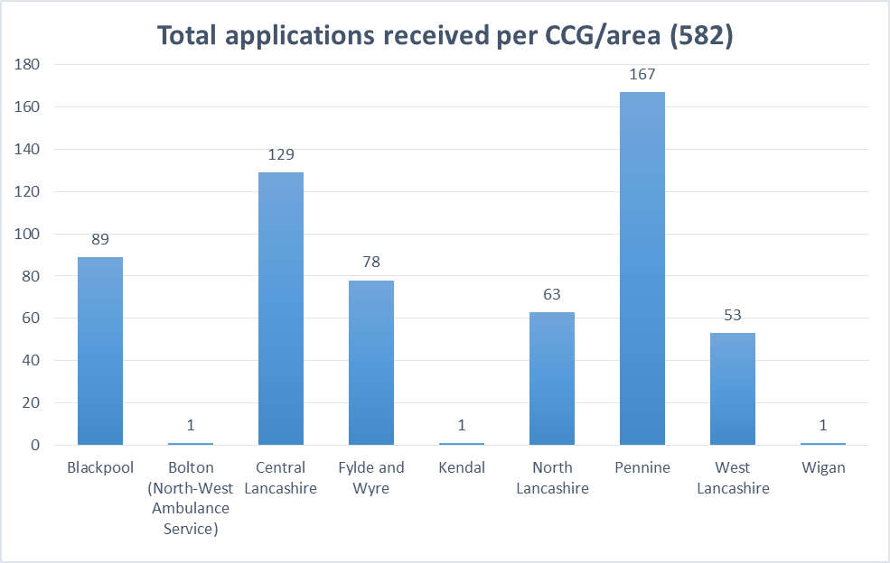
Figure 5: Total applications received per CCG/area

3.12 Figure 6 demonstrates the correlation for each CCG between the number of courses funded, the number of applications received and the number of training places allocated.
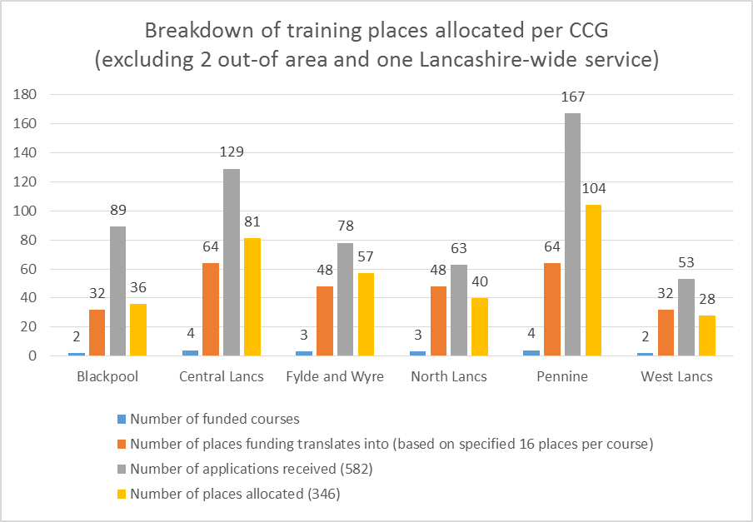
Figure 6: Breakdown of training places allocated per CCG
3.13 A specification of the contract was that all courses should be `multi-agency’. Therefore harm-ed ensured, when allocating places, they were offered to as wide a range of services as possible, with priority given to health, education and social care services. Harm-ed also took into consideration, when examining booking forms, or accompanying emails, that training places were offered only to applicants who were currently actively working with CYP who self-harm. In line with 2.9 above, care was taken to ensure that each training course represented the diversity of the services supporting Lancashire’s CYPFW.
3.14 Although the ideal group size for self-harm training has been found to be around 15-16 participants, harm-ed practised an over-booking system to allow for the fact that cancellations often occur at short notice, particularly with regard to workers from within the health sector. A copy of harm-ed’s allocations policy is attached as Appendix 8.
3.15 Booking forms (Appendices 9a and 9b) were sent out to those interested parties who were eligible to attend the training and, once returned and a place allocated, they were sent a Course Outline (Appendix 10); the Learning Outcomes (Appendix 3); a compulsory Pre-Course Evaluation Questionnaire (Appendix 11); and venue directions. On the booking forms, applicants were asked to state their first choice, second choice and third choice of training date/venue.
3.16 As a general rule, applicants were ordered based on their first choice of training date/venue. Where this could not be met, either due to over-subscription on certain dates or because two applicants from the same service had already been offered a place on a particular course date, then applicants’ second and then third choices were offered. Allocation of training places was also shaped by harm-ed’s `hand-picking’ of participants who would collectively form the most diversely represented groups in order to enhance their learning experience during training. Where more than one participant from the same service attended on a given date, this was often due to the fact that they performed different roles or represented different boroughs.
3.17 Course dates were filled in chronological order where possible. When the second flyer was sent out, applicants were still encouraged to take up the earlier training dates in order to ensure that all courses were filled to capacity. Efforts were also made to ensure that, wherever possible, applicants were allocated a place at their preferred venue(s) even though this may have been different to the CCG area within which they worked. At all times, care was taken to facilitate meaningful multi-agency working (see figures 10 and 11). It was therefore not possible to achieve a full geographical ‘separation’ of the workforce; however harm-ed endeavoured to keep in mind at all times the funding split between the CCGs based on the number of courses each commissioned, and made determined efforts to ensure allocation of places was proportionate to the different levels of funding.
3.18 On occasion, harm-ed would offer a participant a place on a date they had not selected due to over-subscription of certain dates or the need to ensure diverse representation as between the different sectors. In situations where participants were offered a place on a date they had not selected, harm-ed explained the difficulties that had been faced and apologised, inviting the participant to discuss any difficulties they might have with the new date.
3.19 Those eligible applicants who were unable to accept the offer of an alternative date were informed that they would be placed on the reserve list should a place later become available on one of their preferred dates.
3.20 Considerable efforts were made by harm-ed to ensure maximum participation on each course date. Two weeks before each course date, a reminder email was sent and participants were asked to let harm-ed know immediately if they were no longer able to attend. A follow-up reminder was sent one week later, not only to confirm participant attendance but also to remind them to return the pre-course evaluation questionnaire. A final reminder was sent 48 hours before each course to participants. Any participants who were offered a place but were unable to attend were then invited in the first instance to nominate a substitute participant from within their organisation. When no substitute was put forward, an applicant on the reserve list was invited to attend, based on their `best fit’ from a multi-agency perspective for the training day in question. In the event that no ‘eligible’ replacement could be found at short notice, the place was then offered to applicants who had been classed as ‘ineligible’ (mainly service providers for the over 15s) – this was on the guidance of the CL to avoid any ‘empty’ places.
3.21 The participant tracker (Appendix 12) provides a colour-coded breakdown of the 582 applicants, including where applicants whose names were on the existing reserve list have been allocated a place, and those organisations where a participant has cancelled but sent a replacement in their place.
3.22 In an earlier CCG commission, the practice of advising applicants that a £100 penalty may be incurred in the event of less than 24 hours’ notice of non-attendance being given had proven very successful in keeping `Did Not Attends’ (DNAs) to a minimum; it was therefore decided to continue with this. In total, the number of participants who did not attend was just 6. Because all courses were still viable in terms of the number of participants attending each date, it was decided that no penalty charges would be applied. Three DNAs, who had failed to attend for health-related reasons, contacted harm-ed to explain and apologise for their non-attendance.
3.23 Participants who provided more than 48 hours’ notice of their intention to cancel were offered an alternative place on one of the later dates. Reasons given for the cancellations included: meetings being arranged for that date, manager refusing permission for that date due to staffing issues, childcare problems, and funerals. Discretion was also applied to later cancellations, particularly if the reasons given were related to illness or bereavement; these applicants were offered an alternative place on a later course date. There were a few withdrawals of applications where the applicant informed harm-ed of closure of their service; change of role; or where the applicant left their service.
3.24 As mentioned at 3.20 above and in Appendix 8, participants were asked to return their pre-course evaluation questionnaires prior to attending the course. These responses were evaluated and course content further adapted to meet participants’ specific learning needs/expectations. One recurring theme expressed by participants on these forms was an interest in learning more about available local services. From a previous LCC CYPIHT commission, harm-ed had produced and distributed to participants a directory of local services using information gained from the local and area offices of CAMHS and ELCAS and contributions from participants who had attended the training. This booklet was emailed to participants one week before the course date. Participants were asked to read through this booklet prior to attending the course so that any omissions, additions or amendments could be discussed on the day. Note that it was not always possible to send this booklet to applicants on the reserve list one week ahead of the course due to the short notice of many cancellations. In certain cases, the booklets were emailed to participants from the reserve list the day before the training.
3.25 Following each training course, participants were asked to complete an end-of-course evaluation questionnaire (Appendix 4). A summary of both the quantitative and qualitative data from this questionnaire was collated on a Daily Tracker spreadsheet for each of the 18 courses delivered (see Appendix 13). Harm-ed updated both the appropriate CCG and CL on how each course had evaluated within 48 hours of the course.
3.26 After delivery of the final training course, a total of 340 participants had attended one of the training courses; this figure excludes the 6 DNAs. This is 18.1% more than the target figure of 288.
3.27 The final number on the reserve list stands at 227, representing the following sectors:
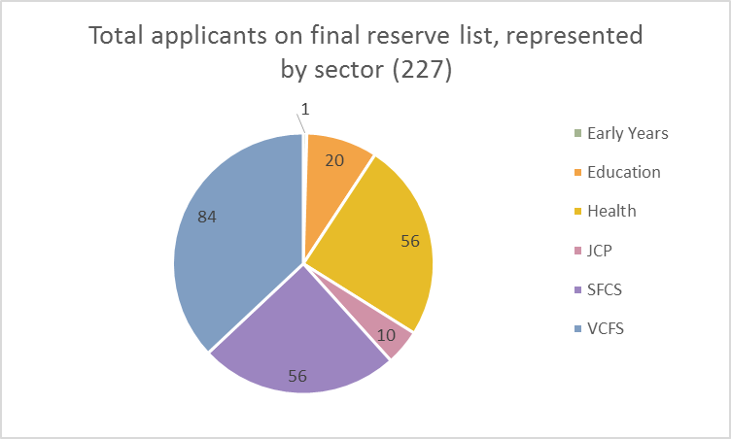
Figure 7: Total applicants on final reserve list, represented by sector
However, this figure includes 50 applications received from organisations which provide services for young people aged over 15. Taking this into consideration, the reserve list based on the criteria for this commission totals 177, and comprises the following sectors:
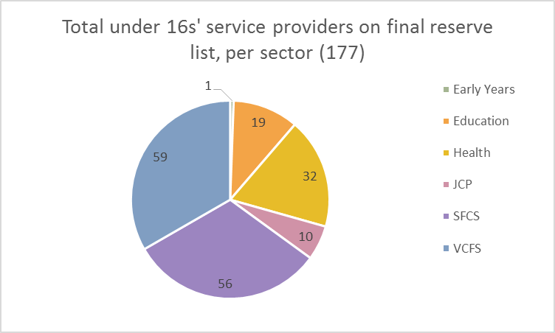
Figure 8: Total under 16s’ service providers on final reserve list, represented by sector

3.28 The final reserve list of 227 applicants were from the following CCG areas:
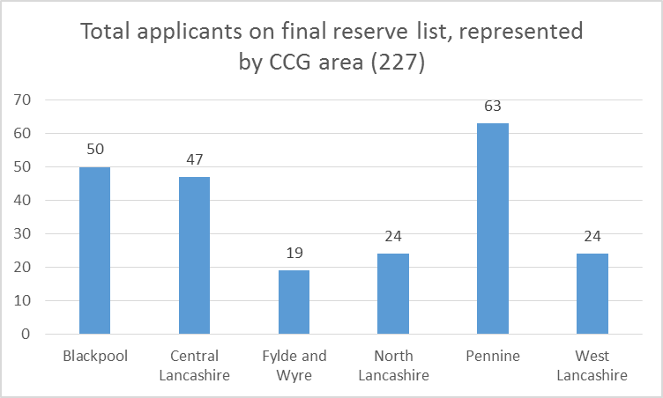
Figure 9: Total applicants on final reserve list, represented by CCG area

Treating course participants as partners
3.29 Harm-ed has respected the CCGs’ desire to treat all course participants as partners and has at all times sought to fully engage participants and involve them in shaping course content in order that the training specifically meets their needs and expectations (see for instance 3.32). The end-of-course evaluation summaries (Appendix 13) show that 100% of all participants returning an end-of-course evaluation form (337) reported that the training had met their needs. As will be seen in section 4 of this report, consistently high levels of participant satisfaction with the training have been recorded.
3.30 Great care was taken by harm-ed to ensure that a meaningful balance was achieved for each course such that there was both proportionate geographical representation and the promotion of whole system relationships across the different sectors of staff working with CYP. Figures 10 and 11 below are demonstrative of this. See Appendix 6 for full breakdown of partners represented at each training course.
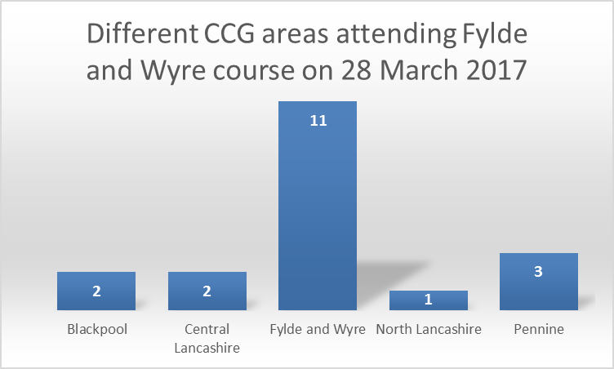
Figure 10: Chart showing different CCG areas represented at Fylde and Wyre course on 28 March 2017

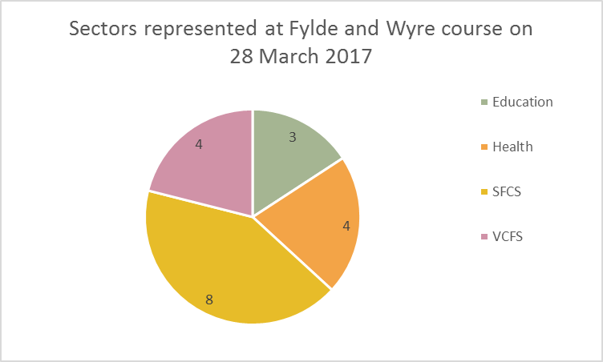
Figure 11: Sectors represented at Wesham, Fylde and Wyre on 28 March 2017
3.31 One of the ways in which harm-ed was able to involve partners in shaping course content was through their responses to the following two questions on the compulsory pre-course evaluation questionnaire:
- “Please describe any specific issues or areas of concern you have regarding self-harm that you would like to be addressed during the training”; and
- “Please state if there is anything else you hope to gain from this training course”

3.32 The responses received were diverse in nature and demonstrated a keen desire amongst partners to improve both their own knowledge and understanding, and the quality and effectiveness of the support they could offer to CYP who self-harm. Furthermore, some responses highlighted the importance of effecting a culture change in the way in which partners perceive the reasons behind CYP self-harming. Below is a sample of responses selected from the health, education and social care sectors in relation to Question 1.
- I am new to the role of public health staff nurse therefore would like to learn a lot from this training, if possible how to approach children who self-inflict harm and refer them on etc. My main concern is checking their safety and asking the best questions to make an assessment
- I haven’t worked with many young people who have self -harmed and I’m looking forward in gaining further information in this area that will inform my practice. I have a high number of teenagers on my caseload and require training in this area.
- Self-harm due to illness such as Diabetes or other lifelong conditions.
- I have had many children saying “I want to kill myself”, they talk about the way they want to kill themselves but then later on they say they are calm and do not want to do anything. My question is around, how I respond to this – I do not want to dismiss it, however, I do not want to prolong it in an unhealthy way. I have had a young child, with attachment difficulties, sink his teeth in to his arms (break the skin and draw blood) when he becomes cross – I see this as a form of self-harm – am I right to think this? Which services can help?
- How to broach the issue with young people and what is the best way to respond to a disclosure
- An opportunity to develop my clinical practice, widen my knowledge base and deal more effectively with self-harming issues in the future
- Links between Child Sexual Exploitation and self-harm
- When a young person shares that they have been self-harming- what is the appropriate course of action? E.g. Safety plans? Does self-harm need to be classed as a safeguarding issue and reported? Is it appropriate to discuss other coping mechanisms as opposed to self-harm?
- When to involve parents if child/ young person does not want them to know. How to address issue with child if you see cuts that they have not told you about.
- Exactly what to say to the child/family concerned. Exactly how to help them on a daily basis in school.
- I hope to gain more understanding of the best way to assess and support young people who use self-harm as a coping strategy and build up a range of alternative coping strategies. I look forward to the training course as I value challenging my own practice if need be, so as not to become complacent and keep my practice up-to-date.
- I am interested in the broader picture of mental distress in young people and children and how that contributes and predisposes them to a pattern of self-harming developing as a way of managing difficult feelings.
- Managing self-harm in youngsters on the autistic spectrum and or with learning disabilities
- I would like to learn more about confidentiality in regards to family and referral pathways
- I would like a better understanding safe self-harm and further ways to safeguard young people who do not meet criteria for mental health services
- Interested in personal accounts from people who self-harm and what people who self-harm find useful in terms of talking about it and potential safer alternative strategies.
- How self-harming differs with age, common ages and is it replaced with other behaviours with age?
- Ways to support a young person without necessarily referring on to another service. Local services. Indicators of self-harm outside of the obvious visuals
- Would be useful to look at further ways to support, more therapeutic intervention… early support etc. Ways of discussion. Reassurance about what I’m already doing and whether I need to be doing more.
- We as an ambulance service attended numerous incidents involving young people. It would be very advantageous for our staff to have a better understanding of self-harming as it is often the ambulance see these young people at the first on set. Being able to offer advice and sign posting at this stage would I believe prevent many young people’s conditions exacerbating to more serious incidents

3.33 Some cross-sector responses given to Question 2 included:
- I would find the whole course beneficial as I do not have great knowledge within this topic. I am looking forward to this training and finding out more on how to approach someone who is self-harming and ways in which I could help.
- What direct help is available? Effective Interventions including long term follow up. Good Web sites (HeadMeds, Thesite.org)
- An understanding of self-harm and assessments. Would like to be able to assist and support a young person in crisis.
- Views of other course participants, and networking opportunities
- Are there any signs to look out for that might tell you a young person is self-harming or likely to self-harm?
- Triggers of self-harm./Types of different self-harm/ Support and Intervention to tackle self-harm
- Knowledge and confidence in dealing with Children In Our Care who self-harm
- Awareness of current appropriate monitored web sites/groups which our young children may be able to contact anonymously if they are unable to seek advice face to face etc.
- I work with children and young people, so I am particularly interested in how to identify it (i.e. groups that are more susceptible to it and warning signs) as well as community resources that could be utilised to help.
- Just an opportunity to talk to different people from different organisations to see this issue from a different perspective.
- Just wanting more awareness of strategies to help young people who self-harm/injure Also would like more information about local support services for young people. Interested to get an understanding of any new evidence and research that I can use in practice
- The online communities where young people share ideas around how to self-harm
- How to educate other professionals, e.g schools to consider their safeguarding policy regarding self-harm
- I hope to be able to offer increased help to the young people I support about this issue by being able to discuss self-harm with them and give them more helpful strategies and information on organisations, websites etc. that can also help. I hope to be able to discuss the course with colleagues so that we can all benefit from this training to some degree.
- A better awareness of the pre-disposing factors leading to self-harm and better ways of supporting/managing clients who are doing so.
- Thinking about ways a young person can communicate their difficulties to their family
- As I am not adept with social media, I would appreciate knowing which sites/social media products are accredited (or at least safe) as I am wary.

3.34 One of the questions on the end-of-course evaluation questionnaire, which participants were asked to complete before leaving, asked: In your opinion, do you feel the training met your needs/personal learning objectives? An analysis of the total responses to this question revealed that 100% of participants who completed the end-of-course evaluation questionnaires (337 out of the 340 who attended) reported that the training had met the needs and personal learning objectives that they had expressed in their pre-course evaluation questionnaire; many commented that the training had far exceeded their expectations.
3.35 As will be seen in section 4 of this report, consistently high levels of participant satisfaction with the training have been recorded.

4.0 QUALITY AND OUTCOMES PERFORMANCE STANDARDS

Harm-ed’s performance against activity/process performance indicators
Production of training delivery plan
4.1 The following delivery plan targets were agreed between the CL and harm-ed:
- Venues to be booked by 28 February 2017
- Marketing flyers to be produced by 7 March 2017
- Flyers to be distributed to CYP workforce by 14 March 2017
- Performance monitoring to take place via regular email and telephone contact and meetings to be scheduled if requested by either party.

4.2 Harm-ed successfully met all agreed deadlines for all of the courses.
Provision of progress reports
4.3 Prior to each and every course date, harm-ed submitted a list of participants to the CCGs detailing their role, organisation and location.
4.4 Regular contact was maintained with the CCGs re numbers of participants booking places on courses.
4.5 Pre-course evaluation form feedback was collated and submitted in order that the CL could gauge participant expectations from the training. Any specific or unusual issues were drawn to CL’s attention.
4.6 The CCGs were provided with a summary of each course’s end-of-course evaluation feedback, plus details of any non-attendees or extra participants attending.
4.7 Any specific issues arising from each training session were raised with the CL and dealt with promptly.
4.8 Where necessary, telephone ‘meetings’ took place with the CL where emerging issues were discussed, eg, relating to eligibility, allocation, etc.
4.9 Ongoing email communication took place with the CL regarding any emerging issues that required clarification, e.g. eligibility of applicants or number and nature of enquiries.
4.10 Interim statistical data was submitted at fortnightly intervals to each CCG. This data included numbers of overall requests for booking forms; number of booking forms received; number of overall participants who had attended training; and breakdown of sectors who had attended training courses.
Number of training courses delivered
4.11 There were total of 18 training courses, which were delivered in the following locations:
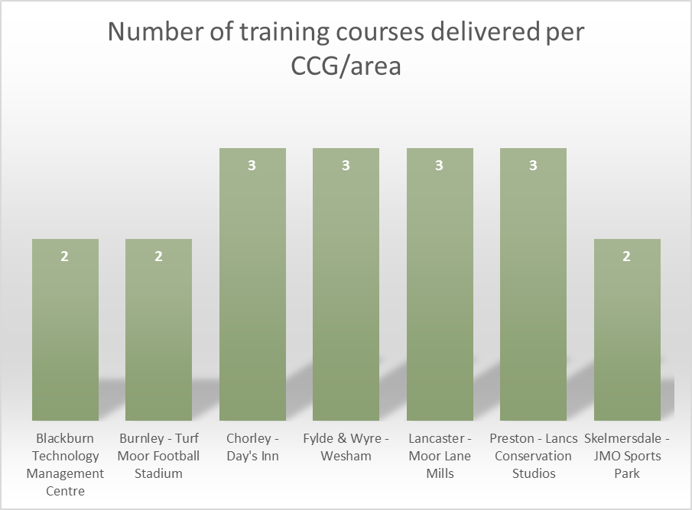
Figure 12: Number of training courses delivered per CCG/area

Total number of course participants
4.12 This commission was to provide training for a minimum of 288 participants (see 2.7). However, harm-ed exceeded this target by 18.1%, training 340 participants in total. The breakdown of participants receiving self-harm training per training venue is as follows:
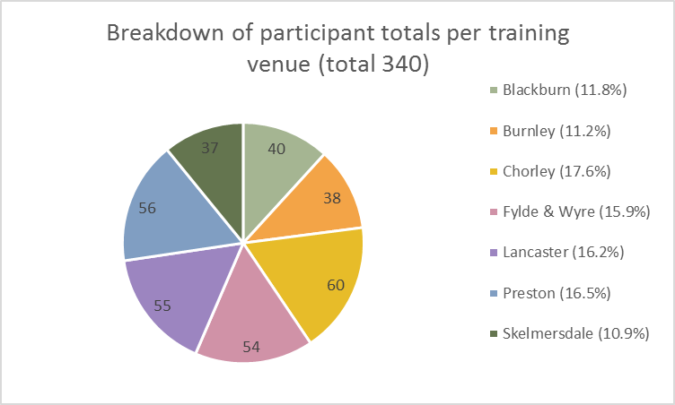
Figure 13: Breakdown of participant totals per training venue
4.13 It was not always possible to ensure that only services within a specific CCG’s area attended only that CCG’s training courses for several reasons. Firstly, the dates on which applicants were available to attend one of the courses often did not coincide with the training dates offered in a particular area. Secondly, some services were provided across a wider geographical spread rather than being confined to a particular CCG area and therefore applicants would choose venues closer to their home or scheduled workplace. Therefore, it was not always within harm-ed’s control to ensure that the allocation of training places was proportionate to the funding split between CCGs. Despite this, it can be seen from figures 6, 10, 12 and 13 that overall proportionate representation was in fact achieved.
Number of applicants receiving training per sector
4.14 Figure 14 provides a breakdown of the total number of applications for places received (582) per sector (including those previously listed on the reserve list – see 3.6 above), compared to the final number attending one of the 18 training courses (340). This demonstrates the consistent promotion of whole system relationships across the different sectors working with CYP.
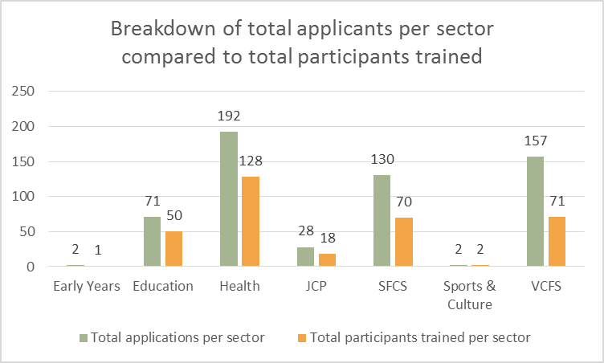
Figure 14: Breakdown of total applicants per sector compared to total participants trained
4.15 From the data in figure 14, it can be seen that prima facie the health and education sectors appear to have been allocated a higher proportion of training places (at 67% and 70% respectively) than has the SFCS sector at 54%. All three were priority sectors for this commission (see 2.9). However, it should be noted from the participant tracker (Appendix 12) that it was within the SFCS sector that the highest numbers of applications were made for multiple training places (31).
Evaluation of the impact that the training has had within health, education and social care sectors and with CYP
4.16 The impact that this training will have on the health, education and social care sectors, and on CYP throughout Lancashire is something that will be evidenced more fully over time, once training has been cascaded down through the various services.
4.17 However, an Impact Assessment Study conducted by harm-ed on behalf of Lancashire County Council in March 2015 found that harm-ed’s self-harm training had had a very positive impact in terms of helping participants to:
- understand the complex nature of self-harm in CYP;
- recognise at an earlier stage risk factors associated with self-harm and signs that a CYP may be self-harming;
- feel more confident in broaching the subject of self-harm with a CYP they suspect of self-harming;
- focus their support on addressing the cause of the self-harm rather than the action itself;
- make more timely and effective referrals; and
- reduce the incidence, frequency and severity of self-harm in CYP

4.18 The same Study has shown that CYP have also felt the benefits of the support that is now being offered by those who have attended self-harm training; in particular, they have responded very positively to the open, empathic and non-judgmental approaches that are now being adopted by those who attended the training.
4.19 An analysis of the end-of-course evaluation questionnaires for this current commission has illustrated that the 18 training courses have had an extremely positive impact on those participants representing the health, education and social care sectors throughout Lancashire. 100% of all 248 participants from these three sectors reported that their needs and personal learning objectives had been fully met by the training, and that they now had an increased knowledge of self-harm; and an increased confidence in the subject area.
4.20 The qualitative data collated from the end-of-course evaluation questionnaires demonstrates very high and consistent levels of satisfaction from participants within all sectors, including the priority sectors of health, education and social care. It also demonstrates recognition of the value of multi-agency working, and a clear determination by participants to apply their new knowledge in the workplace. For example, several participants listed these as the most useful aspects of the training:
- “Helping to look at the issue from a young person's perspective, focussing on them as an individual and less on the self-harm itself. I was shown how to help children keep as safe as possible whilst seeking support.” (PSHE Co-ordinator)
- “Harm-minimisation strategies were useful” (Student Support and Intervention Manager)
- “That self-harm isn't the problem it's just a sign of underlying issues so doesn’t just focus on stopping it.” (Learning Mentor)
- “The personal experiences that were shared. Thinking about it from a young person's perspective especially if considering taking everything away from them.” (School Nurse)
- “Group work and honest experiences/accounts. Thank you so much this was a really helpful honest presentation, really enjoyed the day” (Safeguarding Lead, Health)
- “That sometimes it is ok to just listen - don't take away the control from the young person by trying to do too much” (Counsellor)
- “Personal experience/professional experience shared in group” (Counsellor)
- “Areas about stigma, language, barriers to young people seeking help, stereotypical behaviours that I can challenge” (Cognitive Analytical Therapist)
- “Overall understanding of self-harm – that it is a sign of distress so don't focus too hard on 'stopping' it without acknowledging the underlying distress” (Emotional Health and Wellbeing Practitioner)
- “Working in groups. Multi-agency aspect” (High Intensity Therapist)
- “Shared experiences of the trainer and other group members.” (Senior Staff Nurse)
- “Understanding the perspective of the person who has self-harmed. Helping whilst giving control to the young person” (Deputy Lead, Therapeutic Parent)
- “Group discussions and other people's experiences” (Senior Therapeutic Worker)
- “Boys/men's behaviours. Suicidal intent” (Staff Nurse)
- “Overall understanding of self-harm and reasons for it and ways to approach it” (GP)
- “It was an excellent course and I really am pleased I attended. Lots of new and important tips for how I should deal with a person who self-harms. How to approach/ how to follow these” (GP)
- “Confidence on approaching young people and overall expectations of dealing with self-harm. The presentation was brilliant - kept me fully engaged all day” (Chartered Psychologist)
- “All of it! Most useful, informative and engaging training I've been on for a long time” (Senior CAMHS Practitioner)
- “Awareness that self-harm cannot be looked at in isolation as it is usually just the tip of the iceberg and there are underlying issues.” (Specialist Eating Disorder Nurse)
- “To get us talking between each other instead of just shouting statistics at us” (Stop Smoking Advisor)
- Understanding terminology further i.e. not referring to someone as 'committing suicide' instead saying 'took their own life' as I think these subtleties as to how we communicate very powerful!” (Senior Complex Needs Practitioner)
- “Group work. Knowledge/information sharing. Delivery of the course was excellent” (Early Action Police Officer)
- “Different agencies attending the course and sharing experiences. The personal information from the trainer” (Registered Care Worker)
- “Assurance that I am `doing it right’ and confidence to trust my judgement” (Foster Carer)
- “Being able to support carers with children/young people who self-harm” (Social Worker)

4.21 Further positive feedback was received post-course via email from many participants. Below are some examples taken from emails received from participants working within the health, education and social care sectors (see also 4.28):

Health sector participants:

- “Many thanks Terri. It was a wonderful session with a personal touch. This made it unique; nothing like I have ever experienced.”
- “I would just like to say what an excellent course this was, the facilitator was amazing, obviously very passionate about the subject, and I know this new knowledge will help me in my role.”
- “I really enjoyed this course, the trainer was brilliant. I found it very informative and feel much more confident to broach this subject in the future.”
- “I cannot express how amazing the training day was. I have already spoken to my manager about the training and told her that I think it should be mandatory! I have also been to see the practice development sisters on the children’s ward here at Blackpool and explained the same. … It would be fantastic if you could get into Universities, so that you are training nurses and other professionals prior to them qualifying, so they are more prepared. I see far too many professionals judging people in situations surrounding self-harm. Only the day after the course, I went into work and was handed over a patient who had self -harmed by cutting. The nurse handed over - stating they are just superficial, there not proper cuts - it’s just a scratch - It’s just not acceptable behaviour to be judging a person like this, I explained this and passed on exactly what the trainer had taught us. I have never judged and never will, as I too have been through similar circumstances, I just wish everyone could be non-judgmental.”
- “I felt the training was brilliant and very informative both from a professional and a personal perspective. I will most definitely pass on my knowledge gained from the course and I have emailed the booklet information to my work colleagues. I will bear in mind other organisations that would benefit from this training.”
- “Thank you the course was excellent and the tutor sorry can’t remember how to spell her name was also excellent and had a real passion which came through. A real credit to your organisation. More importantly she will have helped the numerous children we will all come into contact with following this course and our new found awareness. Once again great course which I will share with our safe guarding lead”
- “I really enjoyed the course and would be interested in any upcoming courses that would improve my knowledge and understanding of local mental health services.”
- “Thanks Terri, the training was excellent! The trainer is fantastic. I have learned so much that will enhance my practice in relation to self-harm. Keep up the great work,”
- “Really enjoyed the course, and really impressed with the fab trainer. Will highly recommend to colleagues!”

Education sector participants:

- “It was fantastic. I know that my feedback was okay but I have been meaning to email you today to do it properly. Course content was really useful and relevant. The delivery was brilliant, so often you go to training and people read a power point at you but the trainer was excellent. Obviously, she could relate to the subject matter but she was so inspirational and really made us think about our own views. I will certainly fell much more confident in how is best to approach this subject with pupils and other people. I have fed back to our safeguarding lead as I think it is definitely something we should look at as a whole school”
- “Thank you so much for the course. It really did give me some new insights not only in the subject but also how to broach such a personal subject. Unfortunately, I have already had to put my new knowledge into practice, which has resulted in hopefully a positive outcome for all concerned. Sorry for being bold, but if there are any other relevant courses you feel I could benefit from, (behaviour mentor/Pastoral Officer) and could also benefit my students please could you pass them on. I have no problem paying for my own fees if necessary. I have attended a number of similar courses while working as a behaviour mentor with LCC, but now I work directly with two schools I'm out of the training loop. Anyway, the course was excellent, the instructor was amazing and not only knowledgeable but also very passionate which makes a lot of difference.”
- “An excellent course, superbly presented.”
- “Thanks, today's course was very informative, useful and extremely well-presented. The best course I have been on in ages.”
- “The course was fabulous and will defiantly have an impact on my own personal practice.”
- “Thank you. It was by far the best training I have attended in a long while. I will certainly be recommending it to my colleagues.”
- “Thank you so much. I thought the course was incredibly useful and I am in awe of the trainer's bravery, authenticity and honesty.”
- “The training was one of the best courses I have ever been on. The passion the trainer spoke with about the subject and then the first hand experiences she gave were so powerful. The day was split into a perfect mix of talks, discussions and activities, it was an excellent way to deal with a difficult subject. An excellent presenter. Thank you both so much for your incredible work. “
- “I just wanted to say thank you for yesterday's training course. I found it really informative and interesting. If you are aware of any other similar courses in the area, please could you let me know? I know a course relating to suicide was mentioned yesterday?”
Social care sector participants:

- “I attended the course yesterday over at the Days Inn, Chorley. I would just like to express what a great day of training it was, I have come away with even more knowledge which was great. After the course I actually had a parent call to say her child has been self-harming again and I feel better equipped to deal with this now. The trainer was funny, informative, knowledgeable and exceptionally brave and honest whilst telling her own story. Well done to you all!”
- “I did enjoy the training day and it really got the message home regarding approachability and being calm and ready to listen.”
- “Great course today very, very well delivered and interactive, it's a course that I will be asking my Company to commission for staff”
- “I would just like to say how enjoyable i found today's course; it was very informative and interactive. Your trainer was amazing and the way she delivered the course was brilliant, her self-disclosures really helped to get a different perspective of what a person whom self-harms experiences and how to best support them.”
- “I thought the course was absolutely great and I think it should be compulsory for all people who might have professional contact with young people.”
- “Yesterday was brilliant! I really enjoyed it and it was good to hear from all the experience in the room and although I don't work directly with children and young adults I do think that the information is relevant across the board. I will definitely be putting into practice what I have learnt.”
- “I just want to thank you for the place on the course yesterday. I found it really helpful and made a lot of contacts as well!”
- “The training was brilliant; I will be recommending it to everyone!”
- “I think all staff should go on it to raise awareness as we are all dealing with self - harm daily and unsure of how to best support YP and their families. I will be recommending the course to all social workers”
- “My sister works on the mental health student support team at UCLAN and was interested in the training. Please could you send me some information she can pass onto her team as I think they are keen to book you.”
- “The training was the best training I have been on in a while very educational and insightful I feel I learnt a lot and will use all I learnt in my practice”
- “The training today has been excellent and I will certainly be able to utilise todays learning into practice.”
- “Thank you, the course was very helpful and thought provoking.”
- “I thoroughly enjoyed the course, very informative and took a lot away from the course which I feel will help me in the work I do with children and young people. The course was delivered extremely well in a genuine and realistic approach by the trainer. Please keep me posted if you have any similar courses in the future.”
- “I thought the training was inspirational and I have gained a lot from attending :-) I will mention the in-house training to my managers”
- “Thanks very much. The course was great, a really good mix of learning whilst interacting.”
- “Thank you...the training was exceptional...great delivery...informative...& resourceful...i feel more confident in my own knowledge & skill base to support in this area... I will definitely pass on to colleagues.”

Harm-ed’s performance against quality/outcomes performance indicators
Comparing actual outcomes against target outcomes
4.22 The CCGs set a number of quality and outcomes performance indicators (see 2.4 to 2.9) against which harm-ed collated quantitative and qualitative data from end-of-course evaluation questionnaires (see Appendix 13). These quality and outcomes performance indicators were based on the number of end-of-course evaluation questionnaires completed. As stated at 3.29, a total of 337 out of 340 participants completed their end-of-course evaluation questionnaire. In addition to this, 58 post-course emails containing qualitative data were received by harm-ed (see 4.21 and 4.26).
4.23 Harm-ed produced a breakdown for the CL of all outcomes achieved against targets, together with qualitative data collated, for each course run.
4.24 Figures 15 and 16 (below) show that, against each and every performance indicator, Harm-ed has exceeded targets set – in most cases achieving 100% against target outcomes.

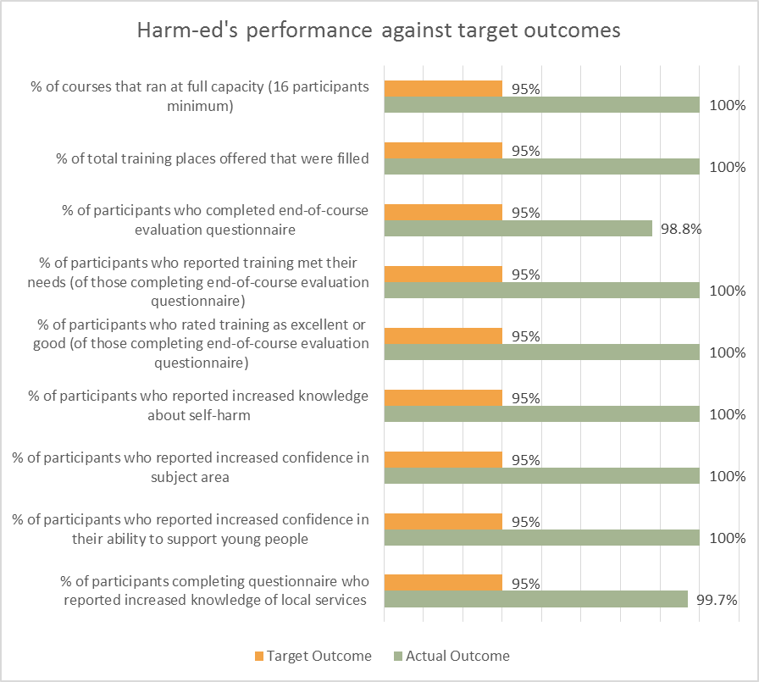
Figure 15: Chart showing Harm-ed's performance against target outcomes

Outcome | Target | Actual
% of courses that ran at full capacity (ie, 16 participants) | 95% | 100%
% of total training places offered that are filled | 95% | 100%
% of participants completing post-course evaluation questionnaire | 95% | 98.8%
% that report training as meeting their needs (of those that complete the post course satisfaction survey) | 95% | 100%
% that rate the training as being excellent or good (of those that complete the post course satisfaction survey) | 95% | 100%
% of participants who report increased knowledge | 95% | 100%
% of participants who report increased confidence in subject area | 95% | 100%
% of participants who report increased confidence in their ability to support young people | 95% | 100%
% of participants who report increased knowledge of local services | 95% | 99.7%*

Figure 16: Table showing Harm-ed's performance against target outcomes
Note: * Due to the often late notice given of cancellations, substitute participants would have had very little time to read the local services booklet that was emailed to them with their joining instructions.
4.25 Overall, 318 (94%) of the 337 participants completing an end-of-course evaluation questionnaire described the training as “excellent”, with the remaining 19 (6%) describing it as “good”.
Impact of training on staff working within CYP services
4.26 The above performance data supports the fact that the self-harm training delivered by harm-ed Limited has had a significant and positive impact on all participants. Further evidence of this can be seen in a small selection of the many positive feedback comments that have been either left on completed end-of-course evaluation questionnaires or sent post-course by email:
End-of-course evaluation questionnaire feedback (see also 4.21 and Appendix 13):
  - “I found everything about the course so useful. I would definitely recommend the training! Having the trainer share her own experiences really bought it home about the impact we, as professionals can have on the patient/service-user's outcomes and well-being” (Community Staff Nurse)
  - “Phrases to say and not to say when supporting young people and how they use self-harm to cope” (Administration and Engagement Officer, Health)
  - “Ensuring my attitudes and language are non-judgemental and that I would have the confidence and competence to work with a young person who was self-harming” (SENCO)
  - “The training was excellent throughout and should be mandatory for the children and young people's workforce” (Children and Young People Health Transformation Co-ordinator)
  - “How a child feels and what not to say to hinder any progress/trust” (Community Staff Nurse)

Participant feedback given on post-course emails (see also 4.21):
- “Fantastic training yesterday, really worthwhile. I think it would be good for our new recruits to receive the training when they start with us, but not sure on dates just yet. I will speak to our Sgt about arranging a date (when we get one)! (JCP)
- “I really enjoyed the course yesterday, and it was very informative. The delivery was excellent too; I have attended so many training courses where the trainer has just read from the PowerPoint, word by word so it was really refreshing to attend engaging training delivered by someone that both has a sense of humour and clearly knows the source material. With regards to the directory, I wanted to check that I am okay to circulate this; I have previously worked within mental health so know of a few organisations that may benefit from this information, or indeed may be appropriate for inclusion.” (VCFS)
- “I just want to say how much I really enjoyed the training yesterday.” (VCFS)
- “The delivery of such a challenging topic was brilliant… I felt fully engaged in the whole day – with interactive opportunities and getting to know other delegates.” (VCFS)
- “Your trainer inspired me with her courage and honesty and she has certainly influenced my practice and understanding.” (VCFS)
- “I believe you also deliver Eating Disorder Training – when and where are these delivered?” (VCFS)

Value for money
4.27 Efforts were made throughout this contract to keep costs to a minimum.
4.28 To take account of historic evidence of non-attendance (estimated at 20%), and to fully utilise each course to meet the high levels of demand, harm-ed operated an over-booking system. This resulted in all 18 courses being over-subscribed. With the improved efficiency introduced in the East Lancashire CCG and Blackburn with Darwen CCG commissions where regular email reminders were sent to those applicants who had been allocated a training date, plus the warning of a penalty being imposed on DNAs (see 3.22), there was a marked decrease in the proportion of DNAs over earlier commissions from Lancashire County Council (with current non-attendance levels at just 1.7%). Consequently, the training numbers ranged from 17 to 20 participants attending, and harm-ed bore the additional subsistence costs involved.
4.29 The contract price for this commission was £29,820 (excluding the impact assessment study which will be conducted in November 2017 – see Appendix 1), with a target of 288 participants to receive training. Figure 11 illustrates the savings per head made as a result of harm-ed training 340 participants:
Contract price | Target number of participants | Actual number of participants | Cost per head
£29,820 | 288 |  | £103.54
 |  | 340 | £87.70
 |  | Total amount saved per head | £15.84

Figure 17: Cost savings per head resulting from actual participants trained exceeding target number
4.30 As a total of 340 participants received training in total under this commission, this meant that the cost per head was £87.70, representing a saving per head of £15.84. Had the cost per head in Figure 11 been applied for all 340 participants trained, then this would have cost £35,203.60, representing 18.05% more than the total funding for this commission. This gives a saving of £5,383.60 and therefore represents excellent value for money in terms of public expenditure.
4.31 If, as is expected, the training received is now cascaded down through the different organisations attending, then the number of CYP workers indirectly benefiting from the knowledge being shared and procedures being established as a result of the self-harm training will expand, making the ultimate cost per head minimal.

The recommendations are provided as an indication of opportunities that appear to exist to improve awareness of self-harm
5.0 RECOMMENDATIONS

5.1 By the end of this commission, the reserve list had 227 names on it, representing one of the highest levels of unmet demand following a series of self-harm training courses delivered by harm-ed. These reserve totals become dwarfed by the inundation of new applications received throughout any new commission for self-harm training. It is therefore recommended that further funding be made available as early as possible to offer either a further series of Lancashire-wide courses or more geographically-targeted training.
5.2 It can be seen from figure 9 (at 3.28) that Blackpool and Pennine have the highest number of applicants listed on the final reserve list (50 and 63 respectively). It is therefore recommended that these two areas are prioritised for further training, particularly as BwD and Blackpool have the highest rate of emergency hospital admissions due to self-harm among 10-24 year olds (see 1.3).
5.3 A significant proportion of participants attending the training, from all but the early years and sports and culture sectors, expressed the view that their colleagues would also benefit from accessing this training. It has also been expressed in previous commissions that refresher days would be beneficial.
5.4 The Royal College of Psychiatrists recommends that schools promote resilience in young people to prevent self-harm, ensuring that bullying is dealt with and an inclusive and peer supportive approach is encouraged. It recognises that school staff feel unskilled and unsupported and recommends that schools prioritise self-harm training along with other mandatory training (Royal College of Psychiatrists, 2014)
5.5 Despite concerted efforts by harm-ed and the CL throughout this commission, the take-up of places from health staff from urgent care and accident and emergency services remained low. Harm-ed had previously considered that this may be due to these services having busier Winter months; however, this appears less likely to be a barrier to attendance given the fact that this commission’s courses ran from March to May. Harm-ed therefore recommends that these services would benefit from consultation to determine how the training might be made more accessible, e.g, shorter course duration, `in-house’ delivery, and at timings that fit better with shift patterns.
5.6 Although there was a small number (6) of GPs attending the training, it is felt that a more targeted approach should be taken to encourage higher take-up of places. The dedicated 2-hour GP event in BwD as part of East Lancs and Blackburn with Darwen CCGs first self-harm training commission was delivered within protected learning time, and this was shown to be an effective way of engaging with this `hard-to-engage’ target group. Harm-ed therefore recommends that a similar format is considered for future commissions since, like schools, GPs are often the first point of contact for a CYP who self-harms.
5.7 There is a need to target self-harm training within the sports and culture sector as only 2 participants represented this sector. This would enable staff working with CYP outside of an educational, residential or health setting to have a much wider awareness of self-harm issues affecting CYP. This would be of benefit for the CYP since they may feel more comfortable in a sports or culture setting because of the informality of the setting, and the voluntary nature of their engagement. Furthermore, such a setting provides staff with an excellent opportunity to be able to detect instances of self-harm at an early stage, for example, in changing rooms where visible signs of self-harm might be more easily observed.
Dialogue or intervention at an early stage can potentially reduce long-term outcomes. Targeting predominantly male-orientated sports or clubs may not only offer awareness to staff but may equally offer reassurance to CYP that help and support is available to them everywhere.
5.8 By enabling interventions to take place as early as possible, this can help prevent the escalation of higher cost interventions and reduce the rate of suicides within vulnerable groups such as boys/young men.

APPENDICES

Appendix 1

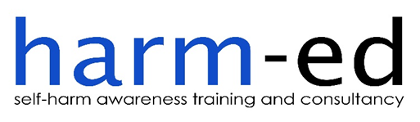

COSTINGS AND COURSE DATES FOR 18 PROPOSED TRAINING COURSES
CAMHS TRANSFORMATION BOARD AND NHS LANCASHIRE CCGs

Breakdown of costs for 18 courses with minimum 16 participants on each course

Training venues/lunches/refreshments: £5,750

Production of course material/delivery of courses/travel costs £17,970

Admin costs, including marketing, recruitment of participants, collation and recording of pre and post-course evaluation data, production of end of contract Evaluation Report £6,100

Total Price: £29,820

Break down as £1,657 per course

Impact Assessment Study and Report £5,000

Total agreed funding £34,820

Training venue No of funded courses Dates

Blackburn 2 28 April and 9 May
Burnley 2 9 March and 19 April
Chorley 3 20 April, 10 May and 17 May
Fylde and Wyre 3 28 March, 3 May and 11 May
Lancaster 3 24 March, 10 April and 15 May
Preston 3 30 March, 24 April and 8 May
Skelmersdale 2 6 April and 5 May

Appendix 2

Memorandum of Agreement

This is a Memorandum Agreement between the Lancashire Clinical Commissioning Groups (the CCGs), comprising Blackpool, Central Lancashire, Fylde and Wyre, North Lancashire, Pennine and West Lancashire (the Commissioners), and harm-ed Limited (Provider).
This Memorandum sets out the conditions of this Agreement which all parties have entered into, whereby the Provider will provide a full day’s training on all eighteen self-harm courses across Lancashire for the CCGs who have accepted the offer on the terms below.
The Term of the Agreement
The Provider will deliver the project within the agreed term set out below:
Start Date: 21 February 2017
Expiry Date: 30 May 2017
Parties to the Agreement
This Agreement is between Lancashire CCGs (the Commissioners) and harm-ed Limited (the Provider).
The agreement payment is confirmed in the sum of £34,820. This sum is apportioned as follows between the CCGs according to the number of courses to be delivered in each CCG area:
Blackpool 2 courses 11.11%
Central Lancashire 4 courses 22.22%
Fylde and Wyre 3 courses 16.66%
North Lancashire 3 courses 16.66%
Pennine 4 courses 22.22%
West Lancashire 2 courses 11.11%
Payment Arrangements
The Provider will send an interim invoice to the Commissioning Lead by 30 March 2017 for the courses run before that date, and further interim invoice once the final training course has been delivered and the Evaluation Report has been submitted by 31 May 2017, and the final invoice at the end of the project delivery once the Impact Assessment Study and Report has been finalised by 31 December 2017.
Invoices should be addressed as follows:
FAO Matt Greene
Finance Manager
NHS West Lancashire CCG
Hilldale
Wigan Road
Ormskirk
Lancashire
L39 2JW

Service Delivery
To design, deliver and evaluate training courses on the subject of children and young people who self-harm to the local workforce including health, education, social care, family and community support groups and leaders of children’s services
- To reduce the risk of suicide in children and young people
- To address the rate of emergency hospital admissions due to self-harm in young people
- To minimise the risk of escalation to crisis point and the need for more intensive support such as CAMHS
- To improve the understanding within the health sector, and other areas including education and social care, CVS of how best to support and signpost young people engaged in self-harm/self-destructive behaviour

Aims and Objectives
- Recognise self-harm as a coping strategy for children/young people facing difficult feelings and situations
- Place self-harm on a continuum of other self-damaging behaviours, including suicide
- Demonstrate increased confidence in broaching the issue/managing disclosure with a child or young person who self-harms
- Identify the social, environmental and psychological factors which influence the prevalence of self-harm amongst children and young people
- Demonstrate an understanding of the functions that self-harm might be serving for the children/young people they are supporting
- Identify the signs that may indicate that a child or young person is self-harming
- Identify the barriers which might prevent a child or young person from disclosing or accessing support for their self-harm and, as a consequence, identify strategies that may help break down these barriers
- Demonstrate understanding in terms of reducing risk and in promoting a therapeutic relationship
- Demonstrate increased confidence in ability to offer a helpful response to a child/young person who self-harms
- State the more common models of response to self-harm, including `alternatives to self-harm’
- Describe how the emotional impact of self-harm on staff/carers can affect the quality of support offered to children/young people as well as impacting on the staff/carer’s own mental wellbeing

Outcomes
- Course to be filled to capacity (DNA’s on the day unavoidable)
- Improve knowledge of self-harm in children and young people
- Improve confidence in the subject of children and young people who self-harm
- Improve confidence in ability to support children and young people who self-harm
- Improve knowledge of local services and support available

Provider Obligations
The Provider will:
- Provide monitoring, reporting, evaluation and feedback to the Commissioners as agreed
- Attend multi-agency project meetings by request
- Discuss with the Commissioners any changes to project plans or failure to deliver the project
- Notify the Commissioners of any adverse incidents
- Possess the appropriate qualifications, experience and skills to perform the duties required of them
- Attend project performance appraisal meetings as required
- Ensure user satisfaction is monitored and reported
- Ensure the organisation maintains appropriate insurance for the life of the project
- Make available to the Commissioning Lead a copy of their complaints procedure
- Provide assurance to the Commissioning Lead in respect of their attainment of Information Governance to Level 2 – https://www.igt.hscic.gov.uk
- Complete the Safeguarding Self-Assessment (SAF) see Appendix B
- Provide their organisation’s Safeguarding Policies

Performance Monitoring
As defined in Appendix A – The Project Specification.
Reporting to be provided monthly to:
cmt.pennine@nhs.net

Termination of Agreement
Either party may cancel this Agreement by giving three months’ notice in writing.

Signatures
This Agreement constitutes the entire Agreement and understanding of the parties.

SIGNED by
…………………………………………………………………
Mark Youlton Signature
For and on behalf of Chief Finance Officer
East Lancashire CCG
Walshaw House, Regent Street, Nelson
Lancashire, BB9 8AS …………………………………………………………………..
Date

SIGNED by
…………………………………………………………………..
Roger Parr Signature
For and on behalf of Chief Finance Officer
Blackburn with Darwen CCG
Fusion House, Evolution Park,
Haslingden Road, Blackburn,
Lancashire, BB1 2FD ……………………………………………………………………
Date

SIGNED by
……………………………………………………………………
Terri Shaw Signature
For harm-ed Limited Managing Director
Head Office
25 Coronation Road, Nelson
Lancashire, BB9 5BS ……………………………………………………………………
Date
Registered in England and Wales
06319428

APPENDIX 3
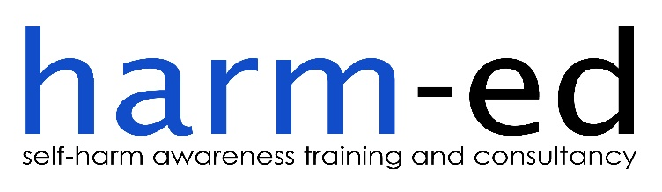

LEARNING OUTCOMES:
CHILDREN AND YOUNG PEOPLE WHO SELF-HARM

By the end of the course, participants will be able to:

- Recognise self-harm as a coping strategy for children/young people facing difficult feelings and situations.

- Place self-harm on a continuum of other self-damaging behaviours, including suicide.

- Identify the social, environmental and psychological factors which influence the prevalence of self-harm amongst children and young people.

- Identify the signs that may indicate that a child or young person is self-harming.

- Recognise the barriers which might prevent a child or young person from disclosing or accessing support for their self-harm, and as a consequence, identify strategies that may help break down these barriers.

- Demonstrate your understanding that purely ‘preventative’ responses to self-harm in children/young people can sometimes be counter-productive in terms of reducing risk and in promoting a therapeutic relationship.

- Show increased confidence in their ability to offer a helpful response to a child/ young person who self-harms.

- Show increased confidence in their ability to offer support and advice to parents/carers of a child/young person who self-harms.

- State the more common models of response to self-harm, including ‘alternatives to self-harm’.

- Describe how the emotional impact of self-harm on staff/carers can affect the quality of support offered to children/young people as well as impacting on the staff/carer’s own mental well-being.

Appendix 4

End of Course Evaluation Questionnaire

We would like your views about the course you have just attended. Your views are very important to us and will help us to improve the content of future training courses.

Course Title: Children and Young People who Self-harm (for Lancashire CCGs)

Date of course:

Q1 | Name of Organisation

Q2 | Your Job Title

Q3 | Your Name (optional)

Q4 | In your opinion, do you think the training ...? (Tick one box for each option)
 |  | Yes |  | No
 | Met its stated aims and objectives | ❑ |  | ❑
 | Content was relevant to your work role | ❑ |  | ❑
 | Met your needs/personal learning objectives | ❑ |  | ❑
Q5 | Was enjoyable  Increased your knowledge about self-harm  Increased your confidence in the subject area  Increased your confidence in your ability to support  young people  Increased your knowledge of local services  If you ticked 'no' to any of the Q4 options, please tell us why | ❑         |  | ❑        

Q6 | Please rate the quality of the training provided (circle the number which best reflects your assessment of the course/trainer):
1 – very poor 2 – poor 3 – satisfactory 4 - good 5 – excellent

Course content | 1 | 2 | 3 | 4 | 5
Trainers’ approach | 1 | 2 | 3 | 4 | 5
Overall assessment of the course | 1 | 2 | 3 | 4 | 5

Q7 | What did you hope to gain from the course?

Q8 | Did you gain what you hoped for?

Q9 | Please make any suggestions  as to how the training could  have been improved to better meet your needs

Q10 | What have been the most useful aspects of the course?

Q11 | What have been the least useful aspects of the course?

I do/do not give permission for my comments to be used in future training and/or promotional material (please delete as applicable)

Many thanks for taking the time to complete this questionnaire. If you wish to receive a copy of the evaluation report for this course, please leave your email address below:

harm-ed Limited, registered in England and Wales 6319428
harm-ed is a not for profit company

Appendix 5
Harm-ed Self-Harm Service Specification

Background
Research studies have shown that by the age of 15-16yrs, 7-14% of adolescents will have self-harmed once in their lifetime. Evidence shows that people who self-harm have an increased risk of suicide, although many people do not intend to take their own life when they self-harm. At least half of those who take their own life have a history of self-harm. In September 2013 a JSNA found that in 2011/2012 Lancashire ranked as one of the top 20% in terms of high numbers of hospital admissions due to self-harm amongst children and young people. Child and Adolescent Mental Health Services (CAMHS) in Lancashire have reported an increase in referrals in respect of self-harm.
Aims
To design, deliver and evaluate training courses on the subject of children and young people who self-harm to the local workforce including health, education, social care, family and community support groups and leaders of children’s services in order to:
- To reduce the risk of suicide in children and young people
- To address the rate of emergency hospital admissions due to self-harm in young people
- To minimise the risk of escalation to crisis point and the need to more intensive support such as CAMHS
- To improve the understanding within the health sector and other areas including education, CVS of how best to support and signpost young people engaged in self-harm/self-destructive behaviour

Objectives
- Recognise self-harm as a coping strategy for children/young people facing difficult feelings and situations
- Place self-harm on a continuum of other self-damaging behaviours, including suicide
- Demonstrate increased confidence in broaching the issue/managing disclosure with a child or young person who self-harms
- Identify the social, environmental and psychological factors which influence the prevalence of self-harm amongst children and young people
- Demonstrate an understanding of the functions that self-harm might be serving for the children/young people they are supporting
- Identify the signs that may indicate that a child or young person is self-harming
- Identify the barriers which might prevent a child or young person from disclosing or accessing support for their self-harm, and as a consequence, identify strategies that may help break down these barriers
- Demonstrate understanding in terms of reducing risk and in promoting a therapeutic relationship
- Demonstrate increased confidence in ability to offer a helpful response to a child/young person who self-harms
- State the more common models of response to self-harm, including ‘alternatives to self-harm’
- Describe how the emotional impact of self-harm on staff/carers can affect the quality of support offered to children/young people as well as impacting on the staff/carer’s own mental wellbeing
Outcomes
- Courses to be filled to capacity (DNA’s on the day unavoidable)
- Improve knowledge of self-harm in children and young people
- Improve confidence in the subject of children and young people who self-harm
- Improve confidence in ability to support children and young people who self-harm
- Improve knowledge of local services and support available

Measures
- Quality and performance outcome indicators to be based on end-of-course evaluation questionnaires completed
- A full report to be provided to the CCG’s

Delivery model
Face-to-face interactive and participatory training courses to be held across Lancashire to:
- increase focus
- adapt sessions to meet training needs of delegates
- allow for differentiation in variety of learning styles
- allow for formative evaluation
- share experiential knowledge of trainer on the issue of self-harm with the group
- allow for questions and shared learning between the delegates

Contracted facilitator
- To provide full-day training at all eighteen self-harm courses across Lancashire

Safeguarding
- Adhere to the CCGs’ Safeguarding Policies and self-assess as compliant with Information Governance to Level 2

Monitoring
- Provider to supply regular updates with regards to the numbers booked on the courses with a breakdown of the sector, borough and indication of bookings from outside the area
- Out-of-area bookings will be allocated only if there are spare places on the courses and will be informed prior to the course date
- Ensure the training places are limited to those supporting children and young people under the age of 16

Appendix 6

BREAKDOWN OF PARTNERS ATTENDING EACH COURSE

Blackburn

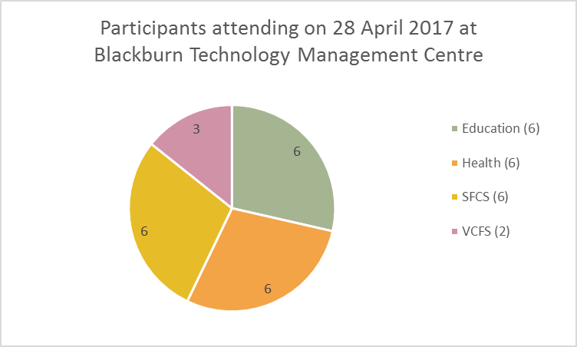

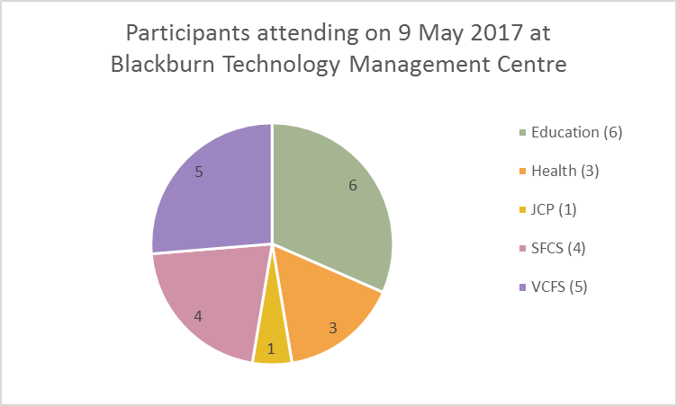

Burnley

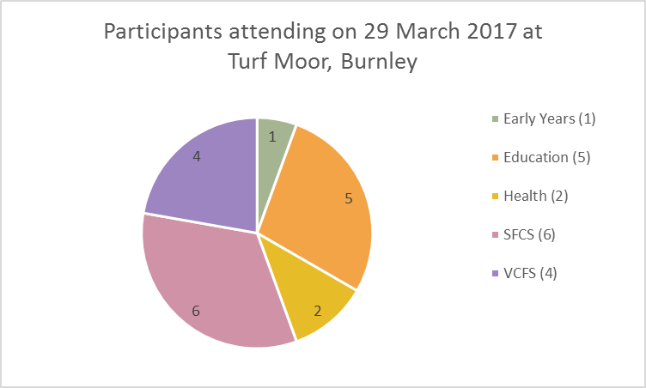

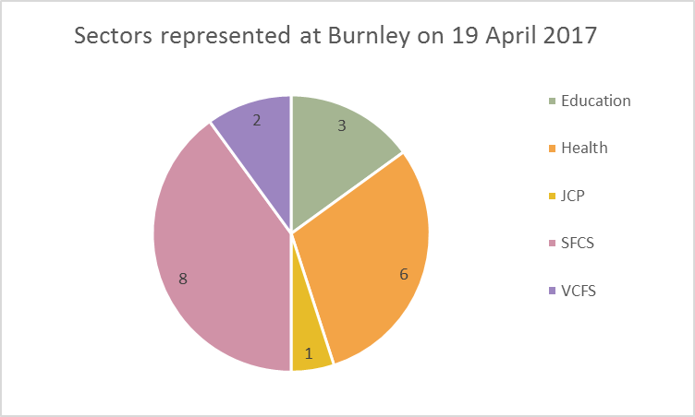

Chorley

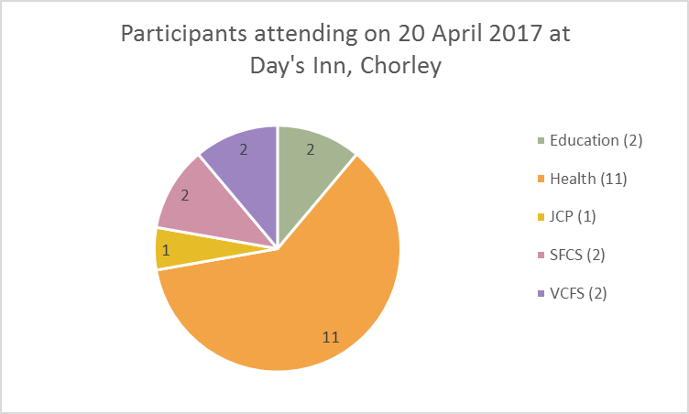

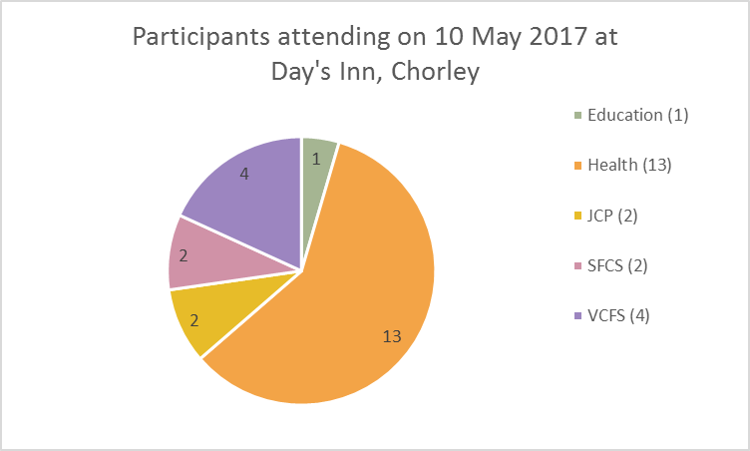

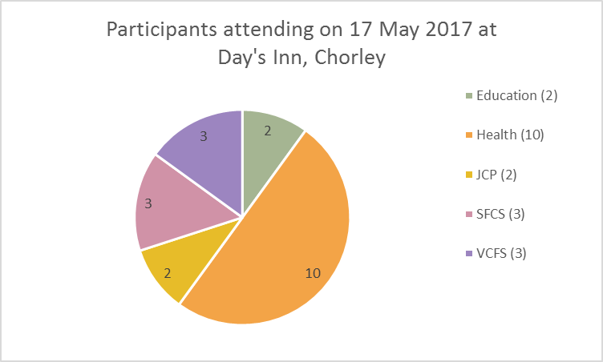

Fylde and Wyre

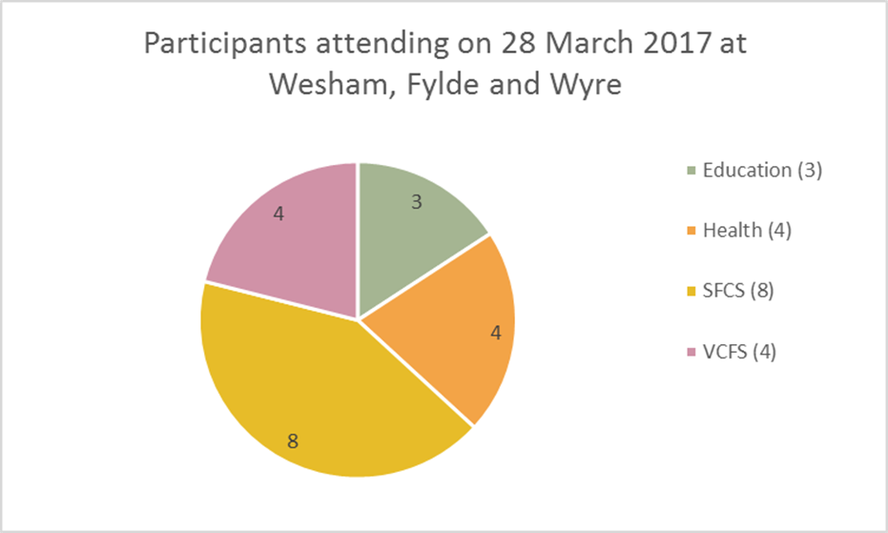

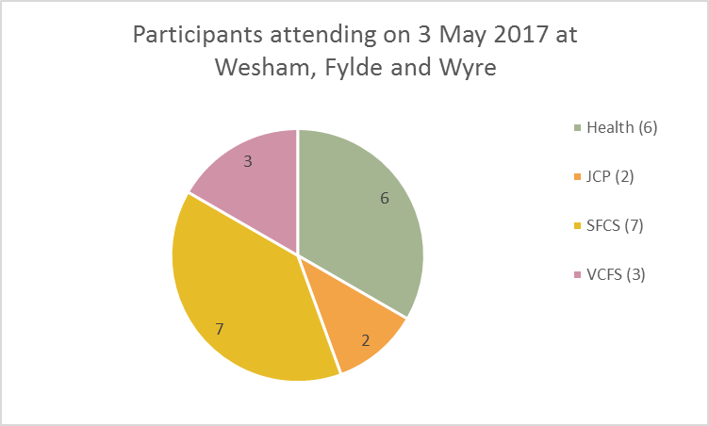

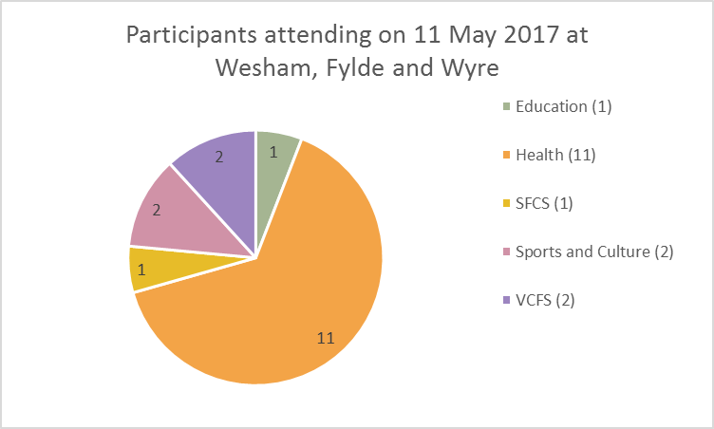

Lancaster

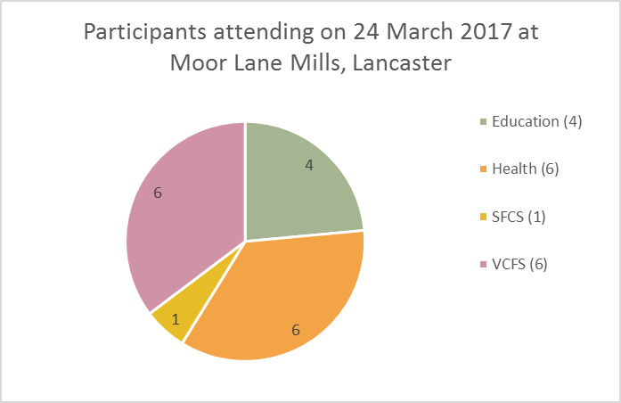

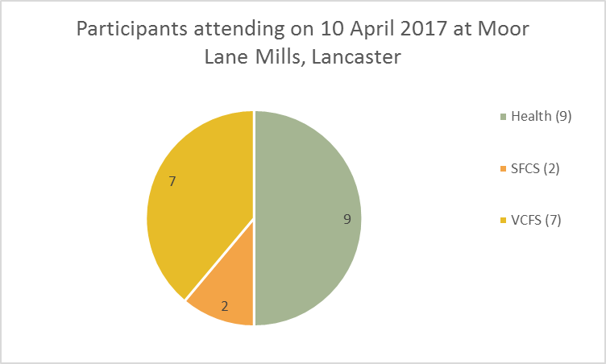

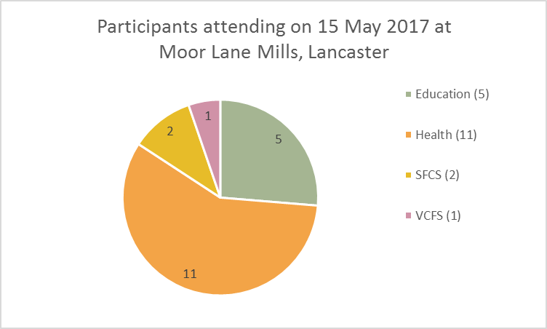

Preston

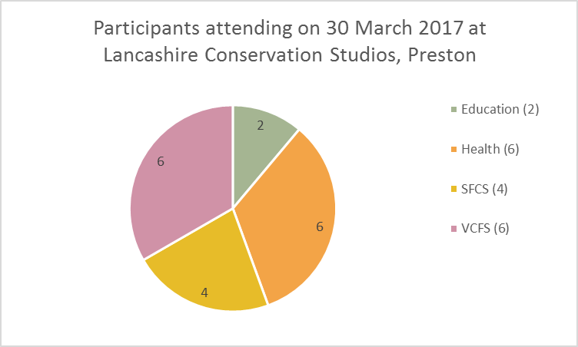

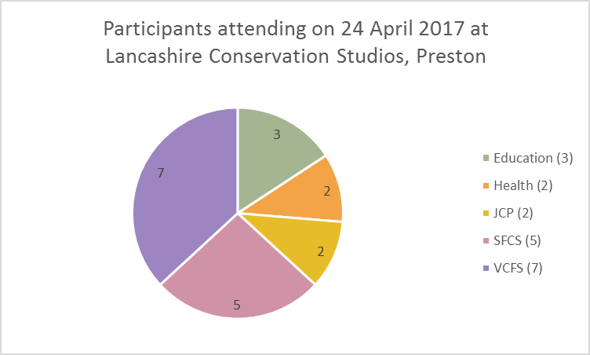

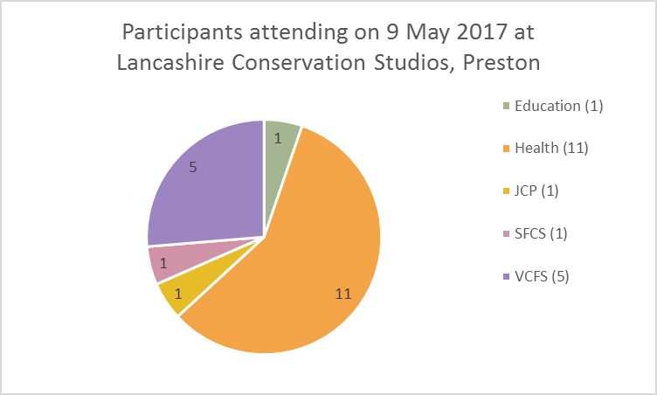
Skelmersdale

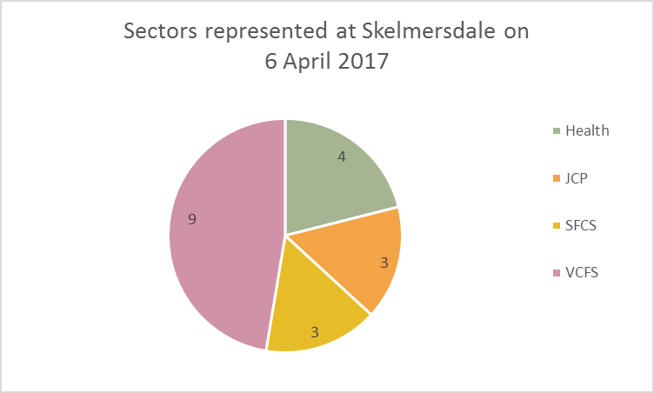

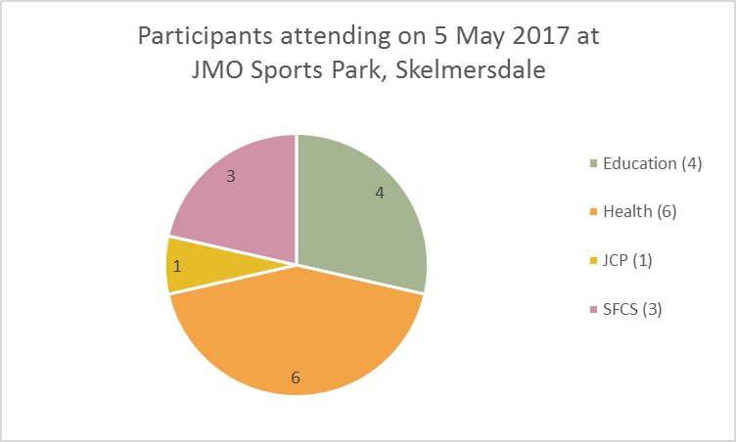

Appendix 7a

Lancashire Collaborative
Partnership of Clinical Commissioning Groups

- Lancashire CAMHS Transformation Board has commissioned harm-ed to deliver a series of free full-day training courses on “Children and Young People who Self-Harm” throughout Lancashire.
- The `Preventing Suicide in England’ cross-government outcomes strategy (2012) supports the delivery of training on suicide and self-harm for staff working in health, social care and education as an effective local intervention in reducing the risk of suicide in children and young people.
- Children and young people are at high risk of self-harm. By age 15-16, 7-14% of adolescents will have self-harmed once in their life. People who self-harm are at increased risk of suicide.
- Allocation of places is limited to the children and young people’s workforce across Lancashire, with priority given to the health, social care and education sectors. Applications will also be accepted from wider children and young people’s services.
- Training will be `multi-agency’ and therefore the need to ensure equal access across different sectors/services may result in limits being placed on the number of places available per service per course.
- The course is suitable for staff/carers working at all levels across all relevant sectors. Below are examples of previous feedback for this training:
- “This was by far the best training I have ever attended” (Early Action Police Officer, 27 October 2016)
- “The training was absolutely FAB!! In fact probably the most interesting/useful and relevant training I have ever been on” (Senior CAMHS Practitioner, 24 October 2016)
- “The training was brilliant and from today my approach to young people who self-harm will change for the better” (Pastoral Manager, 7 February 2017)
Training Venue Training Dates
BURNLEY Turf Moor Football Stadium March 29
FYLDE AND WYRE NHS Fylde and Wyre CCG HQ, Wesham March 28
LANCASTER NHS North Lancs CCG HQ, Moor Lane Mills March 24, April 10
PRESTON Lancashire Conservation Studios March 30
SKELMERSDALE JMO Sports Park April 6

A booking form is available from camhs@harm-ed.co.uk
Free self-harm training
for staff working within the Children and Young People's Trust Workforce
Appendix 7b

Lancashire Collaborative
Partnership of Clinical Commissioning Groups

- Lancashire CAMHS Transformation Board has commissioned harm-ed to deliver a series of free full-day training courses on “Children and Young People who Self-Harm” throughout Lancashire.
- The `Preventing Suicide in England’ cross-government outcomes strategy (2012) supports the delivery of training on suicide and self-harm for staff working in health, social care and education as an effective local intervention in reducing the risk of suicide in children and young people.
- Children and young people are at high risk of self-harm. By age 15-16, 7-14% of adolescents will have self-harmed once in their life. People who self-harm are at increased risk of suicide.
- Allocation of places is limited to the children and young people’s workforce across Lancashire, with priority given to the health, social care and education sectors. Applications will also be accepted from wider children and young people’s services.
- Training will be `multi-agency’ and therefore the need to ensure equal access across different sectors/services may result in limits being placed on the number of places available per service per course.
- The course is suitable for staff/carers working at all levels across all relevant sectors. Below are examples of previous feedback for this training:
- “This was by far the best training I have ever attended” (Early Action Police Officer, 27 October 2016)
- “The training was absolutely FAB!! In fact probably the most interesting/useful and relevant training I have ever been on” (Senior CAMHS Practitioner, 24 October 2016)
- “The training was brilliant and from today my approach to young people who self-harm will change for the better” (Pastoral Manager, 7 February 2017)
Training Venue Training Dates
BLACKBURN Blackburn Technology Management Centre April 28, May 9
BURNLEY Turf Moor Football Stadium April 19
CHORLEY Day’s Inn Hotel April 20, May 10 and 17
FYLDE AND WYRE NHS Fylde and Wyre CCG offices, Wesham May 3 and 11
LANCASTER NHS North Lancs CCG HQ, Moor Lane Mills May 15
PRESTON Lancashire Conservation Studios April 24, May 8
SKELMERSDALE JMO Sports Park May 5
A booking form is available from camhs@harm-ed.co.uk
Free self-harm training
for staff working within the Children and Young People's Trust Workforce
Appendix 8

Harm-ed’s Allocations Process

When it came to the actual allocating of places on courses the following process was used.
- All participants logged on tracker.
- Ensured all applicants’ service provision included children and young people aged 15 and under.
- Looked for multiple applications (4+ generally) from same service and asked the service to nominate one person or more.
- Or if service didn’t reply, looked at who applied first from that service.
- Ordered applicants based on 1st choices.
- Hand-selected applicants who would create the most `multi-agency’ group to enhance learning experience during training.
      - Tried to ensure multiples were from different areas. i.e.
          - Two from same service but from different locations.
          - Or two from different schools but different roles or one primary/one secondary.
- Did this for each day then...
- Ordered applicants based on second choices and did the same process again for each training day and again for the third choices.
- During the allocation process, we gave priority to applicants from health, education and social care services.
- We did our upmost to prioritise applicants who had expressed that they were actively struggling to offer support to CYP who self-harm. We tried to make sure they accessed an earlier date rather than later.
- Once places were allocated we sent out confirmations to participants with the day they had been allocated. For participants that were offered a date they hadn’t selected we apologised and said it was the only place we had available and to please contact us if there was a problem with the date offered.
- We sent out an email to all the applicants who weren’t given a place and said they were on reserve and may contact them to offer a place if one becomes available.
- When a participant who was offered a place was unable to attend, we asked them in the first instance to find another participant within their organisation to attend in their absence if their organisation met our priority criteria (above). When this wasn’t possible we would go back to the reserve list and ask individual participants if they would be willing and available to attend on this day. We would chose applicants that would be the best fit to preserve the multi-agency nature of the group.
Additional Information re meeting the criteria:
Once participants had been allocated a place on a specific course, they were sent a letter of confirmation, course details i.e. course outline, learning outcomes and directions to the venue. They were also requested to fill in the pre-course evaluation form. Prior to delivering the course, the pre-course evaluations were read so that we could identify the main issues and concerns. The course content was then further developed so that we were meeting the participants’ needs.
Since a recurring theme with pre-course evaluations has been the need to know more about available local services, participants during training were asked if they were aware of any local services so that the directory of local services that harm-ed had produced with Lancashire County Council could be expanded and updated. Participants were then sent a copy of this `directory’ at the end of the final course.

Appendix 9a

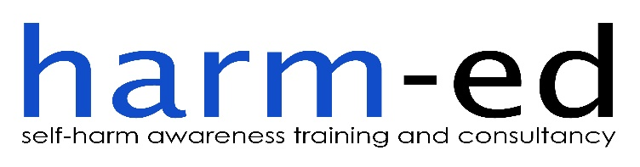
Lancashire Collaborative
Partnership of Clinical Commissioning Groups

BOOKING FORM

I would like to book a place on the free CHILDREN AND YOUNG PEOPLE WHO SELF-HARM training course (Note: please use only one booking form per applicant)
Have you attended harm-ed’s self-harm training before? Yes No

Please state your preferred choice of date/venue (please select from the options in the table below and, wherever possible, please opt for an earlier rather than later date):
Training Venue Training Dates
BURNLEY Turf Moor Football Stadium March 29
FYLDE AND WYRE NHS Fylde and Wyre CCG HQ, Wesham March 28
LANCASTER NHS North Lancs CCG HQ, Moor Lane Mills March 24, April 10
PRESTON Lancashire Conservation Studios March 30
SKELMERSDALE JMO Sports Park April 6

1st Choice | 2nd Choice | 3rd Choice
Each training course runs from 9.30am until 4.30pm. Registration and tea/coffee are available between 9.00am and 9.30am. Lunch will be provided.
Please state any special needs you have (including dietary needs) …………….………………………………………………….……

Your name …………………………………………………………………………………………………………………………………………….……………

Name of your service/organisation ……………………………………………………….…………………………………………………………

Address of your organisation ……….………………………………………………………………………………………………………………….

……………………………………………………………………………………………………………. Post code ……………………………...........

Job title/role ……………………………………………………………………………………… Mobile number …….…………….……….

Email address …………………………….……………..….…………………………..……… Work number ..…………...……………….

Please email your booking form to
camhs@harm-ed.co.uk or post it to Turf Moor Business Hub, Burnley, Lancs, BB10 4BX
Appendix 9b

Lancashire Collaborative
Partnership of Clinical Commissioning Groups
BOOKING FORM

I would like to book a place on the free CHILDREN AND YOUNG PEOPLE WHO SELF-HARM training course (Note: please use only one booking form per applicant)
Have you attended harm-ed’s self-harm training before? Yes No

Please state your preferred choice of date/venue (please select from the options in the table below and, wherever possible, please opt for an earlier rather than later date):
Training Venue Training Dates
BLACKBURN Blackburn Technology Management Centre April 28, May 9
BURNLEY Turf Moor Football Stadium April 19
CHORLEY Day’s Inn Hotel April 20, May 10 and 17
FYLDE AND WYRE NHS Fylde and Wyre CCG offices, Wesham May 3 and 11
LANCASTER NHS North Lancs CCG HQ, Moor Lane Mills May 15
PRESTON Lancashire Conservation Studios April 24, May 8
SKELMERSDALE JMO Sports Park May 5
1st Choice | 2nd Choice | 3rd Choice
Each training course runs from 9.30am until 4.30pm. Registration and tea/coffee are available between 9.00am and 9.30am. Lunch will be provided.
Please state any special needs you have (including dietary needs) ……………………………….….………………………………….

Your name …………………………………………………………………………………………………………………………………………….……………

Name of your service/organisation ……………………………………………………….…………………………………………………………

Address of your organisation ……….………………………………………………………………………………………………………………….

……………………………………………………………………………………………………………. Post code ……………………………...........

Job title/role ……………………………………………………………………………………… Mobile number …….…………….……….

Email address ……………………………………..….…………………………..……… Work number ..…………...……………….

Please email your booking form to
camhs@harm-ed.co.uk or post it to Turf Moor Business Hub, Burnley, Lancs, BB10 4BX
Appendix 10

COURSE OUTLINE: ‘CHILDREN/YOUNG PEOPLE AND SELF-HARM’

9.00am: Refreshments served

9.30am: Section 1
- Brief introduction into the prevalence and diversity of self-harm within society. What is self-injury? How does self-injury relate to self-damaging behaviours, including suicide?
- Participants to identify and discuss terminology and common misconceptions that children/young people who self-harm might experience. What is the subsequent impact of these misconceptions on the child/young person?
- Participants to suggest reasons why a child/young person might self-harm and what functions self-harm serves.

10.45am–11.05am: Break

11.05am: Section 2
- Signs that may indicate that a child/young person is engaging in self-harm.
- Drawing from research and experience, explore possible reasons and emotions behind self-harm, followed by functions that self-injury can serve. Participants will be invited to apply this to their work. There will be an opportunity to listen to an experiential account of self-harm.

12.30pm–1.15pm: Lunch

1.15pm: Section 3
- Identify reasons why a child/young person might not want to ask for help/disclose their self-harm and discuss strategies to help address these potential ‘barriers’.
- Helpful and unhelpful responses to self-injury. Participants will then be invited to discuss and evaluate the approach to self-harm taken by their service.
- Responses that children/young people want in respect of their self-harm.

2.30pm–2.45pm Break

2.45pm Section 4
- Examination of the emotional impact of self-harm and subsequently the importance of recognising and responding to the needs of staff and carers.
- Resources available to support work with self-harm, including local services.
- Summary and evaluation of the training.

4.30pm – Finish

Please note: this course offers participants an understanding of self-harm, along with evidence-based principles to underpin a helpful response to self-harm. Harm-minimisation, as an approach, is briefly discussed. However, for an in-depth exploration of this approach, harm-ed offers a separate "Harm-minimisation for self-harm" course.
Appendix 11

Pre-Course Evaluation Questionnaire

We would like your views about the course you have just attended. Your views are very important to us and will help us to improve the content of future training courses.

Course Title: Children and Young People who Self-harm (for Lancashire CCGs)

Date of course:

Q1 | Name of Organisation

Q2 | Your Job Title

Q3 | Your Name (optional)

Q4 | How do you rate your confidence/knowledge in:
1 – very poor 2 – poor 3 – satisfactory 4 - good 5 – excellent

Awareness of the reasons why a child/young person might self-harm? | 1 | 2 | 3 | 4 | 5
Identifying signs that may indicate a child/young person is self-harming? | 1 | 2 | 3 | 4 | 5
Broaching the issue of self-harm to a child/young person? | 1 | 2 | 3 | 4 | 5
Being able to offer a helpful response to a child/young person who is self-harming? | 1 | 2 | 3 | 4 | 5
Awareness of relevant local services in regards to self-harm? | 1 | 2 | 3 | 4 | 5
Prevalence of self-harm within `high-risk’ groups? | 1 | 2 | 3 | 4 | 5

Q5 | Please describe any specific issues or areas of concern you have regarding self-harm that you would like to be addressed during the training

Q6 | Please state if there is anything else you hope to gain from this training course

Many thanks for taking the time to complete this questionnaire. Your feedback will be used to help shape the course content in order to meet all relevant learning outcomes

harm-ed Limited, registered in England and Wales 6319428
harm-ed is a not for profit company

As Appendices 12 and 13 contain confidential information about participants, a copy of these spreadsheets has been emailed to the CL.

Hawton K, Rodham K, Evans E and Weatherall R (2002) Deliberate self-harm in adolescents: self-report survey in schools in England.
Cooper J, Kapur N, Webb R et al (2005) Suicide after deliberate self-harm: a 4-year cohort study.
Runeson B, Tidemalm D, Ddahlin M et al (2010) Method of attempted suicide as predictor of subsequent successful suicide: national long term cohort study.
HM Government/Department of Health, 2012.
Ibid, at 2.4 and 2.5, p22.
Children and Young People in Lancashire 2014 - JSNA Article: Self Harm, August 2014.
Devaney J, Bunting L, Davidson G, Hayes D, Lazenbatt A, and Spratt T (2012), Still Vulnerable, The Impact of Early Childhood Experiences on Adolescent Suicide and Accidental Death, Northern Ireland Commissioner for Children and Young People.
Appendix 2, page 2.
Appendix 2, Aims and Objectives, page 2.
Appendix 2, page 2.

